

TUTOR ONLINE

Software Requirement Specification

Project Code: TTO

Document Code: TTO– v1.2

**Hoa Lac, 5/6/2017**

Record of change

*A - Added M - Modified D - Deleted

|  |  |  |  |  |
| --- | --- | --- | --- | --- |
| Effective Date | Changed Items | A* M, D | Change Description | New Version |
| 15/05/2017 | Create Software Requirements Specifications | A | Create new | 1.0 |
| 21/05/2017 | Business rule, Non-Functional specification | M | First version | 1.1 |
| 31/05/2017 | Use case diagram | M | Change image Use case diagram | 1.2 |
| 05/06/2017 | Functionality | M | Update Use cases | 2.0 |
| 20/6/2017 | Use case | M | Update all Use cases |  |
|  |  |  |  |  |
|  |  |  |  |  |
|  |  |  |  |  |
|  |  |  |  |  |
|  |  |  |  |  |
|  |  |  |  |  |
|  |  |  |  |  |
|  |  |  |  |  |
|  |  |  |  |  |
|  |  |  |  |  |
|  |  |  |  |  |
|  |  |  |  |  |
|  |  |  |  |  |

SIGNATURE PAGE

|  |  |  |
| --- | --- | --- |
| AUTHOR: | Nguyen Thi Khanh Huyen  Team member  Nguyen Cao Long  Team member | 15/05/2017 |
| REVIEWERS: | Tran Viet Vuong  Project Manager (PM) | 16/05/2017 |
| Nong Thi Hoai Thuong  Team member | 16/05/2017 |
| APPROVAL: | Phan Truong Lam  Supervisor | 17/05/2017 |

TABLE OF CONTENTS

1 Introduction 7

1.1 Purpose 7

1.2 Scope 7

1.3 Definitions, Acronyms 7

1.4 System Purpose 8

1.5 References 8

1.6 Overview 8

2 Overall Description 10

2.1 System Overview 10

2.2 Use Case Diagram 11

2.3 Product Features 11

2.4 Entity-Relationship Model 15

2.4.1 Entity-Relationship Model 15

2.4.2 Entity details 15

3 Functional Requirements 18

3.1 User role. 18

1. Front-end user. 18

2. Backend user. 19

3.2 Use Cases 20

➢ Front-end user 20

1. Student 20

2. Parent 21

3. Tutor 21

4. Guest 22

➢ Back-end user 22

5. Supporter 22

6. Accountant 23

7. Manager 24

8. System admin 25

3.3 Business rules 25

3.4 Usability 32

3.5 Reliability 32

3.6 Performance 33

3.7 Supportability 33

3.8 Design Constraints 34

3.9 On-line User Documentation and Help System Requirements 34

3.10 Purchased Components 34

3.11 Interfaces 34

3.12 Licensing Requirements 35

3.13 Legal, Copyright, and Other Notices 35

3.14 Applicable Standards 35

4 Supporting Information 37

# Introduction

## Purpose

This document is created as the introduction for project Tutor Online- the System for Tutor and Students, who want to learn online. In this document, we provide the describing of general requirement and non-function requirements. These requirements will assure that the system will correctly and reliably perform its intended functionality. This specification will provide general, as well as specific requirements to be used in the design, testing and validation of the system. All members work (code, design, test,…) based on the information what provided in this document.

## Scope

Tutor Online system is a website that built on ASP.net MVC5 and Entity Framework 6, for students to learn online. The document applies to many stages of developing the system:

* It is used for project manager and supervisors to negotiate.
* It is very important for designing, developing, manufacturing, testing, and maintaining the system:

+ Designers must know what the system is and what function it needs to have

+ Developers must know what the system does, how each function is implemented and the interface between components in system

+ Testers must know that to check if the system meets the requirements or not

## Definitions, Acronyms

|  |  |  |
| --- | --- | --- |
| Acronym | Definition | Note |
| TTO | Tutor Online |  |
| SRS | Software Requirements Specifications |  |
| Admin | TTO’s administrator |  |
| Manager | TTO’s manager |  |
| Guest | TTO’s guest |  |
| Student | TTO’s student |  |
| Parent | TTO’s parent |  |
| Accountant | TTO’s accountant |  |
| Supporter | TTO’s supporter |  |

**Table 2-1:** Definition and Acronyms

## System Purpose

Nowadays, the knowledge of subjects is growing and be more difficult, the parents need to finds a good tutor to complements the knowledge for their children. Grasped this fact, we have made an idea and developed a e-learning system named Tutor Online together. In here, the students can be comfortable to considering or choosing a appropriate tutor for their learning needs, be flexible for making a studying schedule, choosing a studying location is not restrained. The tutor and student can study online everywhere via skype. The parents can manage their children’s information, schedule, and studying quality based on the feedback of tutor after a lesson or a course easily.

## References

|  |  |  |
| --- | --- | --- |
| No | Document | Source/ Web Address |
| 1 | Software Requirements Specification Template | FPT Software Cop. |

## Overview

The rest of the SRS contain 3 sections:

* Introduction: provides an overview of this document. It includes the purpose, scope, definitions, acronyms, system purpose, references and overview.
* Overall Description: describes the general factors that affect to the product and their requirements.
* Specific Requirement: Contains all requirements to a level of detail sufficient to help designers and testers satisfy those requirements.

# Overall Description

## System Overview

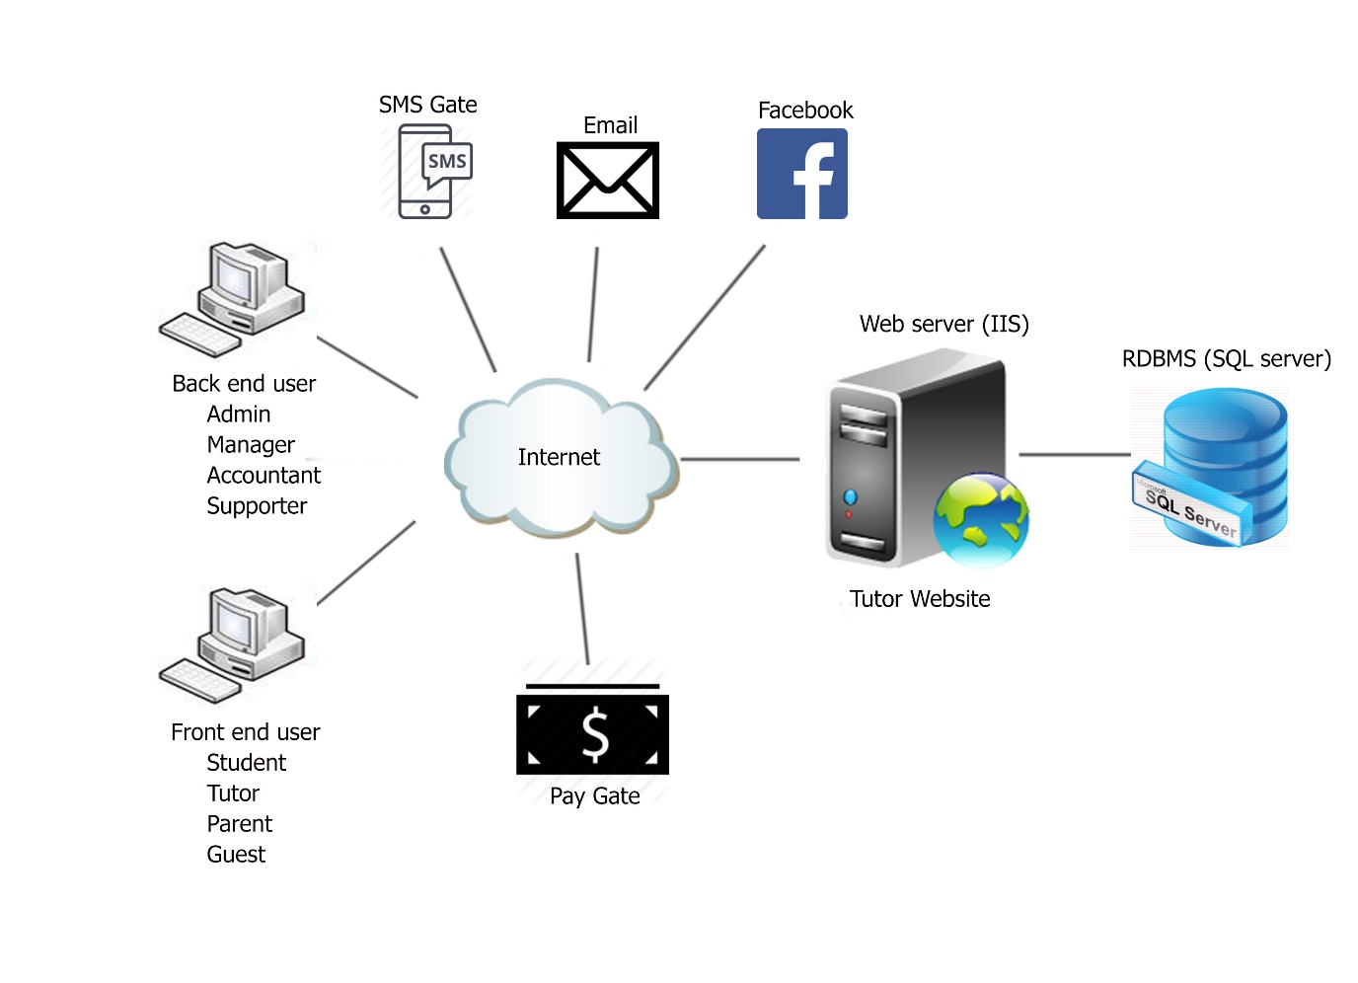

Figure 2-1: System Overview

## Use Case Diagram

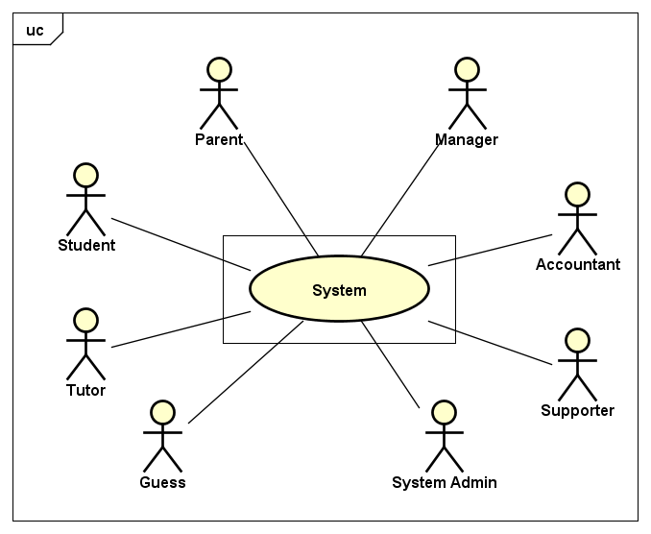

**Figure 2-2:** Use case diagram of TTO

## Product Features

|  |  |  |  |
| --- | --- | --- | --- |
| UC No. | Group of Functions | Function | Glossary |
| Student/Tutor/Parent/Manager/Accountant/Supporter/Admin | | | |
| UC001 | Common | Login |  |
| UC002 | Logout |  |
| UC003 | Manage personal account | View profile |  |
| UC004 | Update profile |  |
| UC005 | Change password |  |
| All | | | |
| UC006 | View | View homepage |  |
| UC007 | View category page |  |
| UC008 | View course |  |
| UC009 | View introduction |  |
| UC010 | View user help |  |
| Student/Parent/Tutor/Guest | | | |
| UC011 | View | View transaction history |  |
| UC012 | View account balance |  |
| UC013 | View feedback |  |
| Student/Parent | | | |
| UC014 | View | View study result |  |
| System admin | | | |
| UC015 | Manage back-end users | Add account |  |
| UC016 | Edit account |  |
| UC017 | Delete account |  |
| Manager | | | |
| UC018 | Manage category | Add category |  |
| UC019 | Edit category |  |
| UC020 | Delete category |  |
| UC021 | Manage Subject | Add subject |  |
| UC022 | Edit subject |  |
| UC023 | Delete subject |  |
| UC024 | Manage Pre-tutor & Tutor’CV | Download CV |  |
| UC025 | Change the status of CV | Approved, pending, read, unread, reject |
| UC026 | Manage Document | Add file |  |
| UC027 | Edit file |  |
| UC028 | Delete file |  |
| Accountant | | | |
| UC029 | Manage front-end user’s transaction | View transaction history |  |
| UC030 | Export to file excel |  |
| UC031 | Modify balance | Modify student balance |  |
| UC032 | Modify tutor balance |  |
| Supporter | | | |
| UC033 |  | Read requests from front-end users |  |
| UC034 |  | Answer requests from front-end users |  |
| Student | | | |
| UC035 |  | Register course |  |
| UC036 |  | View the registered course |  |
| UC037 |  | Register for a trial |  |
| UC038 |  | Set class schedule |  |
| UC039 |  | Cancel class schedule |  |
| UC040 |  | View class schedule |  |
| UC041 |  | Do the test |  |
| UC042 |  | Write feedbacks for the tutor |  |
| UC043 |  | View tutor's profile |  |
| Tutor | | | |
| UC044 |  | Set a schedule |  |
| UC045 |  | Cancel a schedule |  |
| UC046 |  | View a schedule |  |
| UC047 |  | Write feedbacks for the student |  |
| UC048 |  | View student's profile |  |
| Parent | | | |
| UC049 |  | Pay money to the student's account |  |
| Guest | | | |
| UC050 |  | Register |  |
| UC051 |  | Upload CV |  |
| UC052 |  | Send request to supporter |  |

## Entity-Relationship Model

## Entity-Relationship Model

Phát vẽ

## Entity details

#### 2.4.2.1: Users Table

|  |  |  |  |  |
| --- | --- | --- | --- | --- |
| No | Field Name | Type | Mandatory | Description |
| 1 | Id | Number | Y | User’s id |
| 2 | Username | String | Y | User’s username |
| 3 | First_name | String |  | User’s firstname |
| 4 | Last_name | String |  | User’s lastname |
| 5 | Email | String | Y | User’s email |
| 6 | Gender | Number |  | User’s gender |
| 7 | Password | String | Y | User’s password |
| 8 | Date_of_birth | Date |  | User’s date of birth |
| 9 | Avatar | String | Y | User’s avatar |
| 10 | Cv | String |  | User’s CV |
| 11 | Language | String |  | User’s language |
| 12 | Country | String |  | User’s country |
| 13 | Role | Number | Y | User’s role |
| 14 | Remember_token | String |  | Remember user |
| 15 | Created_at | Date |  | The time that user was created |
| 16 | Updated_at | Date |  | The time that user was updated |
| 18 | Deleted_at | Date |  | The time that user was disabled |

Table 2.4.2‑1: Users table

#### Roles Table

|  |  |  |  |  |
| --- | --- | --- | --- | --- |
| No | Field Name | Type | Mandatory | Description |
| 1 | Id | Number | Y | Role’s id |
| 2 | Role_title | String | Y | Role’s title |
| 3 | Role_description | String | Y | Role’s description |
| 4 | Created_at | Date |  | The time that role was assigned to |
| 5 | Updated_at | Date |  | The time that role was updated |
| 6 | Deleted_at | Date |  | The time that role was disabled |

Table 2.4.2‑2: Roles table

#### Courses Table

|  |  |  |  |  |
| --- | --- | --- | --- | --- |
| No | Field Name | Type | Mandatory | Description |
| 1 | Id | Number | Y | Course’s id |
| 2 | Thumbnail | String | Y | Thumbnail’s URL |
| 3 | Name | String | Y | Course’s name |
| 4 | Description | String | Y | Description about course |
| 5 | Age | Number |  | The age at which the course target at |
| 6 | Added_by | Number | Y | User’s id who added this course (Include Teacher, Admin, Super Admin) |
| 7 | Last_updated_by | Number | Y | User’s id who updated this course last time (Include Teacher, Admin, Super Admin) |
| 8 | Created_at | Date |  | The time that course was created |
| 9 | Updated_at | Date |  | The time that course was updated |
| 10 | Deleted_at | Date |  | The time that course was disabled |

# Functional Requirements

## User role.

## Front-end user.

### Student.

Học viên là lớp người dùng sử dụng hệ thống với mục đích Managehọc tập, đặt lịch với gia sư, kiểm tra quá trình học tập của mình thông qua các đánh giá của hệ thống. Bên cạnh đó, học viên là người sẽ nhận được trợ giúp của đội ngũ hỗ trợ trong quá trình học cũng như đội ngũ hệ thống nếu có vấn đề về kĩ thuật.

### Tutor

Gia sư là lớp người dùng sử dụng hệ thống cho việc Managegiảng dạy. Các chức năng cơ bản dành cho gia sư sẽ là Managethông tin cá nhân, Managea schedule, View đánh giá của học viên và thực hiện đánh giá học viên.

### Phụ huynh

Phụ huynh là lớp người dùng sử dụng hệ thống với mục đích Managehọc viên. Manageaccount cá nhân, Manageaccount học viên là những chức năng mà người dùng phụ huynh sẽ được cung cấp.

### Guest

Khách hàng là đối tượng người dùng chưa có account có hệ thống. Account khách hàng có thể sử dụng tất cả những chức năng chung của hệ thống như: Đăng ký, giới thiệu,….

## Backend user.

### System Admin

Là người hiểu về hệ thống nhất theo khía cạnh kĩ thuật, system admin sẽ hỗ trợ học viên và gia sư nếu có vấn đề về hệ thống. Ngoài ra, system admin cũng là người chịu trách nhiệm bảo trì và cập nhật hệ thống.

### Supporter

Supporter là người hiểu rõ về các chương trình học, các chương trình khuyến mãi, thông tin gia sư hay tất cả những thông tin liên quan khác để có thể giúp đỡ cho học viên trong quá trình học tập một cách tốt nhất.

### Manager

Manager là người quản lý, đưa ra quyết định với tất cả những vấn đề liên quan đến nhân sự, kinh doanh cũng như nội dung của hệ thống. Chức năng chính được cung cấp cho manager sẽ bao gồm những chức năng thống kê và chỉnh Edit chương trình học…

### Accountant

Chịu trách nhiệm về những hoạt động tài chính của hệ thống, kiểm tra luồng tiền ra vào. Lớp người dùng này chủ yếu được cung cấp những chức năng thống kê về tài chính để có thể thực hiện 1 cách thuận tiện nhất.

## Use Cases

## Front-end user

## Student

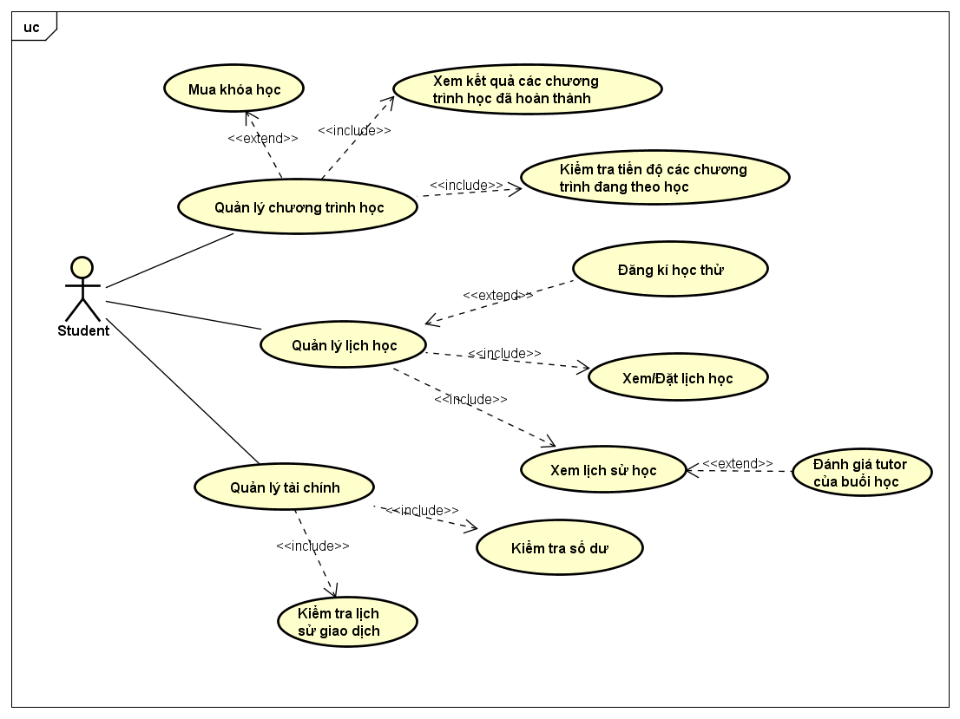

## Parent

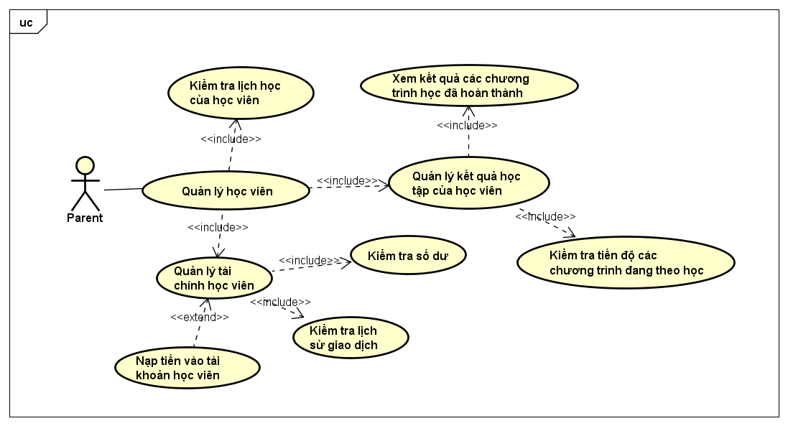

## Tutor

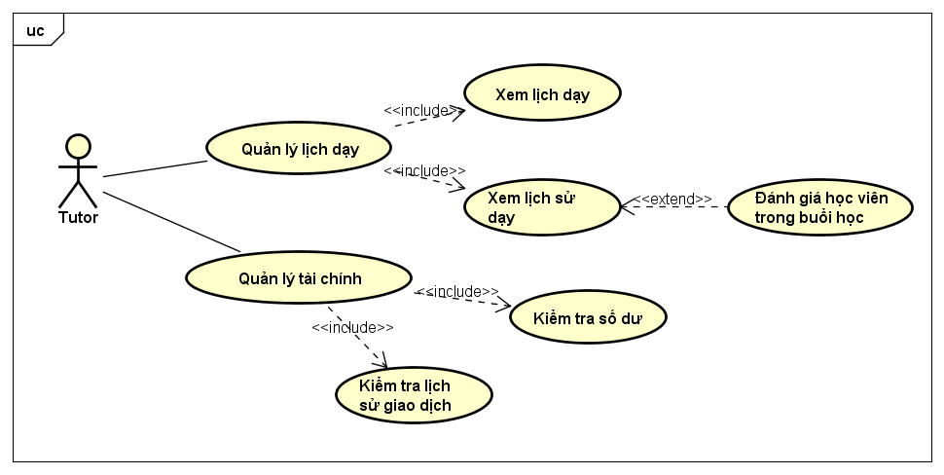

## Guest

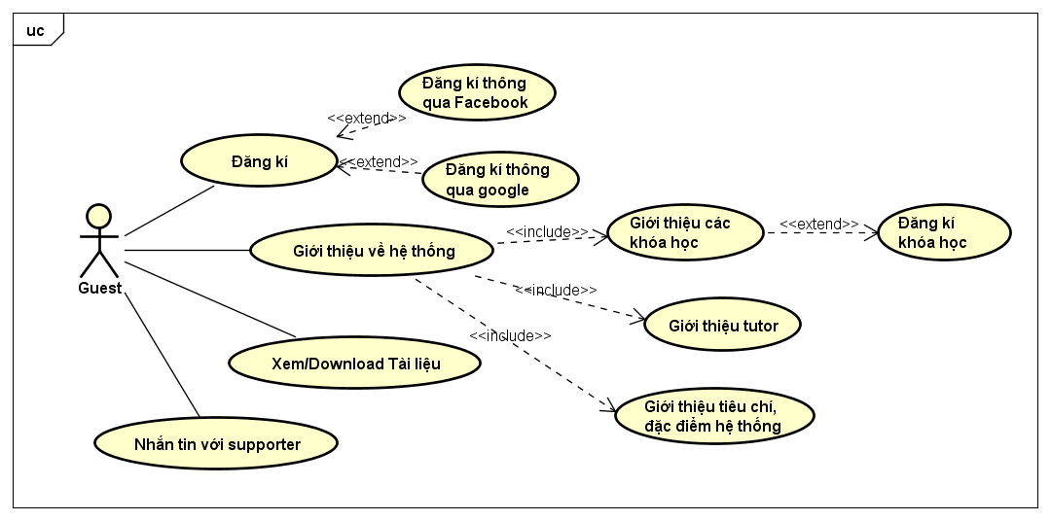

## Back-end user

## Supporter

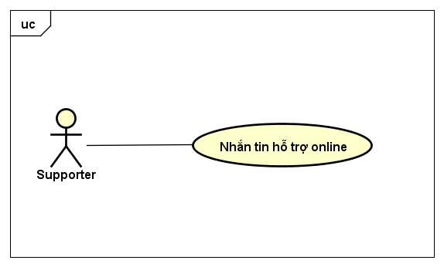

## Accountant

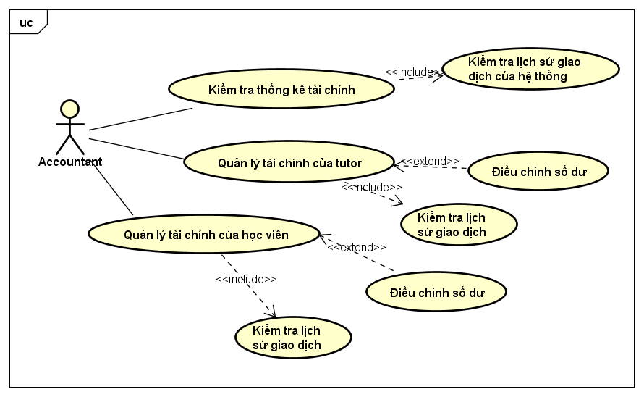

## Manager

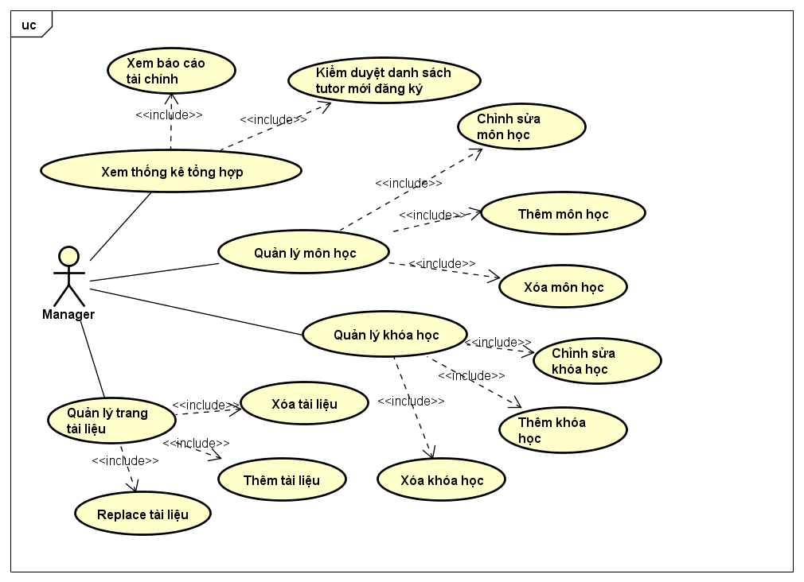

## System admin

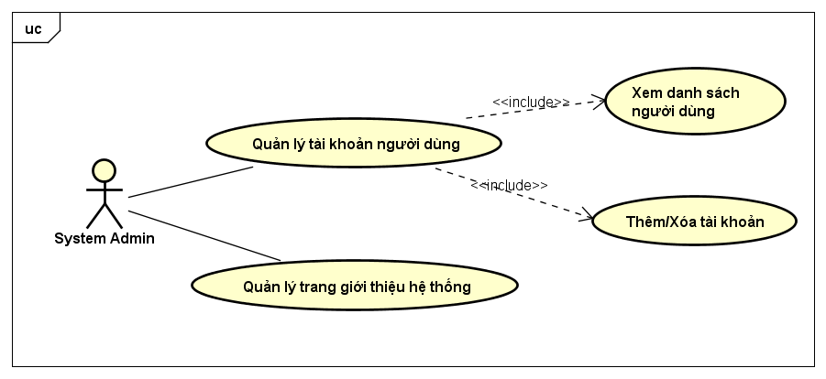

## Business rules

|  |  |  |  |  |  |
| --- | --- | --- | --- | --- | --- |
| No | Function | Item | Validation | Description | Error Message |
| B1 | Register/Update profile | Username (Text field) | Not empty | Message is displayed when user doesn’t enter name | Please fill out this field |
| B2 | Register/Update profile | Username (Text field) | Contain 6-191 characters | Message is displayed when user enter less than 6 characters | The username must be at least 6 characters. |
| B3 | Register/Update profile | Username (Text field) | No duplicate | Message is displayed when username is existed | The username has already been taken. |
| B4 | Register/Update profile | Username (Text field) | Not contain special symbols | Message is displayed when username contains special symbols | The username may only contain letters, numbers, and dashes. |
| B5 | Register/Update profile | Username (Text field) | Not contain only dashes | Message is displayed when username contains only dashes | The username field is required. |
| B6 | Register/Update profile | First name (Text field) | Not empty | Message is displayed when user doesn’t enter name | Please fill out this field |
| B7 | Register/Update profile | First name (Text field) | Not contain special symbols or numbers | Message is displayed when first name contains special symbols or numbers | The first-name may only contain letters. |
| B8 | Register/Update profile | First name (Text field) | Not contain only dashes | Message is displayed when first name contains only dashes | The first name field is required. |
| B9 | Register/Update profile | Last name (Text field) | Not empty | Message is displayed when user doesn’t enter name | Please fill out this field |
| B10 | Register/Update profile | Last name (Text field) | Not contain special symbols or numbers | Message is displayed when last name contains special symbols or numbers | The last-name may only contain letters. |
| B11 | Register/Update profile | Last name (Text field) | Not contain only dashes | Message is displayed when last name contains only dashes | The last name field is required. |
| B12 | Register/Update profile | Email  (Text field) | Not empty | Message is displayed when user doesn’t enter email address | The email address is required. |
| B13 | Register/Update profile | Email  (Text field) | Incorrect format | Message is displayed when email doesn’t contain character “@” and “.” | Please enter a valid email address. |
| B14 | Register/Update profile | Email (Text field) | No duplicate | Message is displayed when email is existed | The email has already been taken. |
| B15 | Register/Update profile/Change password | Password (Text field) | Not empty | Message is displayed when username doesn’t enter password | Please fill out this field. |
| B16 | Register/Update profile | Password (Text field) | Contain 6-24 characters | Message is displayed when user enter password less than 6 characters | Your password must have at least 6 characters. |
| B17 | Register/Update profile | Password (Text field) | Not contain only dashes | Message is displayed when password contains only dashes | The password is required. |
| B18 | Register | Confirm password (Text field) | Match password | Message is displayed when user enter “Confirm password” different from “Password” | The password confirmation does not match. |
| B19 | Register | Confirm password (Text field) | Not empty | Message is displayed when user doesn’t enter confirm password | Please fill out this field |
| B20 | Register/Update profile | Date-of-birth  (Date time) | Incorrect format | Message is displayed when entered date of birth not follow by mm-dd-yyyy format | The date-of-birth is not a valid date. |
| B21 | Register/Update profile | Date-of-birth  (Date time) | 18 years old | Message is displayed when entered date of birth to current date is not enough 18 years | You must be 18 years or older. |
| B22 | Register | CV file  (File) | Incorrect file format | Message is displayed when uploaded wrong file format(accepted file format are doc, docx & pdf) | No file selected |
| B23 | Register | CV file  (File) | Over file size | Message is displayed when uploaded over 10 megabytes size CV | The cv may not be greater than 10240 kilobytes. |
| B24 | Update profile | Avatar image  (File) | Over file size | Message is displayed when uploaded over 1000x1000 pixels or 1 megabytes image | The maximum size of your avatar is 1000x1000 pixels or 1mb. |
| B25 | Update profile | Avatar image  (File) | Incorrect file format | Message is displayed when uploaded wrong image file format(accepted image format are .png & .jpg) | Only .jpg or .png is accepted. |
| B26 | Login | Email (Text field) | Correct email | Message is displayed when user enter an email does not exist | These credentials do not match our records. |
| B27 | Login | Password (Text field) | Correct password | Message is displayed when user enter incorrect password | These credentials do not match our records. |
| B28 | Login | Email (Text field) | Not empty | Message is displayed when user does not enter email | Please fill out this field. |
| B29 | Login | Password (Text field) | Not empty | Message is displayed when user does not enter password | Please fill out this field. |
| B30 | Change password | New password  (Text field) | Not empty | Message is displayed when user doesn’t enter new password | Please fill out this field. |
| B31 | Change password | New password  (Text field) | Contain at least 6 characters | Message is displayed when user enter new password less than 6 characters | Password must be at minimum of 6 characters. |
| B32 | Change password | New password  (Text field) | Contain more than 24 characters | Message is displayed when user enter new password more than 24 characters | Password must be at maximum of 24 characters. |
| B33 | Change password | Confirm password (Text field) | Match password | Message is displayed when user enter “Confirm new password” different from “New password” | The password confirmation does not match. |
| B34 | Change password | Confirm password (Text field) | Not empty | Message is displayed when user doesn’t enter confirm password | Please fill out this field |
| B35 | Change password | Current password  (Text field) | Not empty | Message is displayed when user doesn’t enter current password | Please fill out this field |
| B36 | Change password | Current password  (Text field) | Correct password | Message is displayed when user enter password different from current password | Incorrect current password. Please try again. |

## Functionality

## Student/Tutor/Parent/Manager/Accountant/ Supporter/Admin

#### Common

|  |  |  |  |
| --- | --- | --- | --- |
| Use case ID | UC001 | Version | 1.0 |
| Use case Name | Login | | |
| Created by | HuyenNTK | Date | 21/6/2017 |
| Actor | Student, Tutor, Parent, Manager, Accountant, Supporter, Admin | Priority | High |
| Summary | Login to an account on system | | |
| Goal | Login | | |
| Triggers | Click vào Login trên thanh menu | | |
| Preconditions | User is currently not logged in | | |
| Post conditions | * Log this account into system * Redirect User to Homepage | | |
| Main Success Scenario | | | |
| Step | Actor’s event | System response | |
| 1 | Click on “Log in” button |  | |
| 2 |  | Display Login Page | |
| 3 | Enter Email & Password |  | |
| 4 | Click on “Login” button |  | |
| 5 |  | Log account with entered Username into system | |
| 6 |  | Redirect User to Homepage | |
|  | | | |
| Alternative Scenario: N/A | | | |
| Extensions | | | |
| ExT1 | At step 3, actor does not fill require fields | | |
| Step | Actor’s event | System response | |
| 1 | Actor does not fill required fields |  | |
| 2 | Click on “Login” button |  | |
| 3 |  | Display message “Please fill out this field.” | |
| ExT2 | At step 3, actor enter wrong e-mail or unregister e-mail | | |
| Step | Actor’s event | System response | |
| 1 | Actor enter wrong e-mail or unregister e-mail |  | |
| 2 | Click on “Login” button |  | |
| 3 |  | Display message “Email is wrong.” | |
| ExT3 | At step 3, actor enter wrong password | | |
| Step | Actor’s event | System response | |
| 1 | Actor enter wrong password |  | |
| 2 | Click on “Login” button |  | |
| 3 |  | Display message “Password is wrong.” | |
| Relationships | |  | |
| Business rules | |  | |

Table 3.4.1‑1: Login use case

|  |  |  |  |
| --- | --- | --- | --- |
| Use case ID | UC002 | Version | 1.0 |
| Use case Name | Logout | | |
| Created by | HuyenNTK | Date | 21/6/2017 |
| Actor | Student, Tutor, Parent, Manager, Accountant, Supporter, Admin | Priority | Medium |
| Summary | Logout an Account | | |
| Goal | Logout | | |
| Triggers | Click vào Logout trên thanh menu | | |
| Preconditions | User logged into system | | |
| Post conditions | - Log User out from system  - Redirect User to Homepage as Guest | | |
| Main Success Scenario | | | |
| Step | Actor’s event | System response | |
| 1 | Click on “Log out” button |  | |
| 2 |  | Display Homepage as Guest | |
|  | | | |
| Alternative Scenario: N/A | | | |
| Relationships | |  | |
| Business rules | |  | |

Table 3.4.1‑2: Logout use case

#### Manage personal account

|  |  |  |  |
| --- | --- | --- | --- |
| Use case ID | UC003 | Version | 1.0 |
| Use case Name | View profile | | |
| Created by | HuyenNTK | Date | 21/6/2017 |
| Actor | Student, Tutor, Parent, Manager, Accountant, Supporter, Admin | Priority | High |
| Summary | View information of User’s Account | | |
| Goal | View profile | | |
| Triggers | Click vào Manage Account trên thanh menu | | |
| Preconditions | User logged into system | | |
| Post conditions | Display Account Info Page | | |
| Main Success Scenario | | | |
| Step | Actor’s event | System response | |
| 1 | Click on user’s avatar on Header and choose “Manage account” |  | |
| 2 |  | Redirect User to User profile page | |
| Relationships | |  | |
| Business rules | |  | |

Table 3.4.1‑3: View profile use case

|  |  |  |  |
| --- | --- | --- | --- |
| Use case ID | UC004 | Version | 1.0 |
| Use case Name | Update profile | | |
| Created by | HuyenNTK | Date | 21/6/2017 |
| Actor | Student, Tutor, Parent, Manager, Accountant, Supporter, Admin | Priority | Medium |
| Summary | Update information of Account | | |
| Goal | Update profile | | |
| Triggers | Click vào Update trên User’s profile page | | |
| Preconditions | - User logged into system  - User is on User’s profile page | | |
| Post conditions | Account’s Information will be saved & update into Database | | |
| Main Success Scenario | | | |
| Step | Actor’s event | System response | |
| 1 | Edit own account’s information include upload avatar, edit user name, choose gender, change e-mail, date of birth, country and password |  | |
| 2 | Click on “Save” button |  | |
| 3 |  | Get new information & update into Database | |
| 4 |  | Reload User profile page with new information | |
|  | | | |
| Alternative Scenario: N/A | | | |
| Extensions | | | |
| ExT1 | At step 2, required fields were not filled | | |
| Step | Actor’s event | System response | |
| 1 | All required were blank |  | |
| 2 | Click on “Save” button |  | |
| 3 |  | Display message: “Please fill out this field” | |
| ExT2 | At step 2, actor enter only dashes in username field | | |
| Step | Actor’s event | System response | |
| 1 | Enter only dashes in username field |  | |
| 2 | Click on “Save” button |  | |
| 3 |  | Display message: “The username field is required.” | |
| ExT3 | At step 2, actor enters special characters in username field | | |
| Step | Actor’s event | System response | |
| 1 | User enters special characters |  | |
| 2 | Click on “Save” button |  | |
| 3 |  | Display message: “The username may only contain letters, numbers, and dashes.” | |
| ExT4 | At step 2, actor changes to a registered e-mail | | |
| Step | Actor’s event | System response | |
| 1 | User changes to a registered e-mail |  | |
| 2 | Click on “Save” button |  | |
| 3 |  | Display message: “The email has already been taken.” | |
| ExT5 | At step 2, actor enters an incorrect date time format | | |
| Step | Actor’s event | System response | |
| 1 | User enters an incorrect date time format |  | |
| 2 | Click on “Save” button |  | |
| 3 |  | Display message: "The date-of-birth is not a valid date." | |
| ExT6 | At step 2, actor uploads incorrect image format | | |
| Step | Actor’s event | System response | |
| 1 | Click on avatar and choose a file that not an image or incorrect image format |  | |
| 2 |  | Display message: “Only .jpg or .png is accepted.” | |
| Relationships | |  | |
| Business rules | |  | |

Table 3.4.1‑4: Update profile use case

|  |  |  |  |
| --- | --- | --- | --- |
| Use case ID | UC005 | Version | 1.0 |
| Use case Name | Change password | | |
| Created by | HuyenNTK | Date | 21/6/2017 |
| Actor | Student, Tutor, Parent, Manager, Accountant, Supporter, Admin | Priority | High |
| Summary | Change Password of Account | | |
| Goal | Change password | | |
| Triggers | Click vào Change password trên trang profile | | |
| Preconditions | - User logged into system  - User is on User profile Page | | |
| Post conditions | New password will be saved & update into Database | | |
| Main Success Scenario | | | |
| Step | Actor’s event | System response | |
| 1 | Click on “Change Password” button |  | |
| 2 |  | Display change password dialog | |
| 3 | Enter old password, new password and confirmation of new password |  | |
| 4 | Click on “Change” button |  | |
| 5 |  | Website get new Password & update into Database | |
| 6 |  | System redirect to profile page and display successfully changed password message: “**Your password has been successfully changed.**” | |
|  | | | |
| Alternative Scenario: N/A | | | |
| Extensions | | | |
| ExT1 | At step 3, actor enters wrong old password | | |
| Step | Actor’s event | System response | |
| 1 | Actor enter wrong old password |  | |
| 2 | Click on “Change” button |  | |
| 3 |  | Display message: “Password is wrong.” | |
| ExT2 | At step 3, actor enters new password and confirm new password does not match | | |
| Step | Actor’s event | System response | |
| 1 | Actor enter new password different to confirm new password |  | |
| 2 | Click on “Change” button |  | |
| 3 |  | Display message: “The password confirmation does not match.” | |
| ExT3 | At step 3, actor does not fill required field | | |
| Step | Actor’s event | System response | |
| 1 | Actor does not fill required field |  | |
| 2 | Click on “Change” button |  | |
| 3 |  | Display message: “Please fill out this field.” | |
| ExT4 | At step 3, actor enter new password has less than 6 characters | | |
| Step | Actor’s event | System response | |
| 1 | Actor enter new password has less than 6 characters |  | |
| 2 | Click on “Change” button |  | |
| 3 |  | Display message: “Password must be at minimum of 6 characters.” | |
| ExT5 | At step 3, actor enter new password has more than 24 characters | | |
| Step | Actor’s event | System response | |
| 1 | Actor enter new password has more than 24 characters |  | |
| 2 | Click on “Change” button |  | |
| 3 |  | Display message: “Password must be at maximum of 24 characters.” | |
| ExT6 | At step 3, actor enter new password same as old password | | |
| Step | Actor’s event | System response | |
| 1 | Actor enter new password same as old password |  | |
| 2 | Click on “Change” button |  | |
| 3 |  | Display message: “Your new password is the same as the current one.” | |
| ExT7 | At step 4, actor click on “Cancel” button | | |
| Step | Actor’s event | System response | |
| 1 | Click on “Cancel” button |  | |
| 2 |  | Close change password dialog and redirect to profile page | |
| Relationships | |  | |
| Business rules | |  | |

Table 3.4.1‑5: Change password use case

## All

#### View

|  |  |  |  |
| --- | --- | --- | --- |
| Use case ID | UC006 | Version | 1.0 |
| Use case Name | View homepage | | |
| Created by | HuyenNTK | Date | 21/6/2017 |
| Actor | Guest, Student, Tutor, Parent, Manager, Accountant, Supporter, Admin | Priority | High |
| Summary | Back to homepage | | |
| Goal | View homepage | | |
| Triggers | Click vào Home trên thanh menu | | |
| Preconditions | User is on any page on KRV Website | | |
| Post conditions | Redirect user to homepage | | |
| Main Success Scenario | | | |
| Step | Actor’s event | System response | |
| 1 | Click on “Home” button or “Tutor Online” logo |  | |
| 2 |  | Redirect user to homepage | |
| Relationships | |  | |
| Business rules | |  | |

Table 3.4.2‑1: View Homepage use case

|  |  |  |  |
| --- | --- | --- | --- |
| Use case ID | UC007 | Version | 1.0 |
| Use case Name | View category page | | |
| Created by | HuyenNTK | Date | 21/6/2017 |
| Actor | Guest, Student, Tutor, Parent, Manager, Accountant, Supporter, Admin | Priority | High |
| Summary | View list category | | |
| Goal | View category page | | |
| Triggers | Click vào Category trên thanh menu | | |
| Preconditions | User is on any page on KRV Website | | |
| Post conditions | Redirect user to category page | | |
| Main Success Scenario | | | |
| Step | Actor’s event | System response | |
| 1 | Click on “Category” on header |  | |
| 2 |  | Redirect user to category page | |
| Relationships | |  | |
| Business rules | |  | |

Table 3.4.2‑2: View category page use case

|  |  |  |  |
| --- | --- | --- | --- |
| Use case ID | UC008 | Version | 1.0 |
| Use case Name | View course | | |
| Created by | HuyenNTK | Date | 21/6/2017 |
| Actor | Guest, Student, Tutor, Parent, Manager, Accountant, Supporter, Admin | Priority | High |
| Summary | View list course (subject) | | |
| Goal | View course page | | |
| Triggers | Click vào Course trên thanh menu | | |
| Preconditions | User is on any page on KRV Website | | |
| Post conditions | Redirect user to course page | | |
| Main Success Scenario | | | |
| Step | Actor’s event | System response | |
| 1 | Click on “Course” on header |  | |
| 2 |  | Redirect user to course page | |
| Relationships | |  | |
| Business rules | |  | |

Table 3.4.2‑3: View course page use case

|  |  |  |  |
| --- | --- | --- | --- |
| Use case ID | UC009 | Version | 1.0 |
| Use case Name | View introduction | | |
| Created by | HuyenNTK | Date | 21/6/2017 |
| Actor | Guest, Student, Tutor, Parent, Manager, Accountant, Supporter, Admin | Priority | High |
| Summary | View introduction | | |
| Goal | View introduction page | | |
| Triggers | Click vào Introduction trên thanh menu | | |
| Preconditions | User is on any page on KRV Website | | |
| Post conditions | Redirect user to introduction page | | |
| Main Success Scenario | | | |
| Step | Actor’s event | System response | |
| 1 | Click on “Introduction” on header |  | |
| 2 |  | Redirect user to Introduction page | |
| Relationships | |  | |
| Business rules | |  | |

Table 3.4.2‑4: Introduction page use case

|  |  |  |  |
| --- | --- | --- | --- |
| Use case ID | UC010 | Version | 1.0 |
| Use case Name | View user help | | |
| Created by | HuyenNTK | Date | 21/6/2017 |
| Actor | Guest, Student, Tutor, Parent, Manager, Accountant, Supporter, Admin | Priority | High |
| Summary | View user help page | | |
| Goal | View user help | | |
| Triggers | Click vào Help trên thanh menu | | |
| Preconditions | User is on any page on KRV Website | | |
| Post conditions | Redirect user to User help page | | |
| Main Success Scenario | | | | Main Success Scenario |
| Step | Actor’s event | System response | |
| 1 | Click on “Help” on header |  | |
| 2 |  | Redirect user to User help page | |
| Relationships | |  | |
| Business rules | |  | |

Table 3.4.2‑5: User help page use case

## Student/Tutor/Parent/Guest

#### View

|  |  |  |  |
| --- | --- | --- | --- |
| Use case ID | UC011 | Version | 1.0 |
| Use case Name | View transaction history | | |
| Created by | HuyenNTK | Date | 21/6/2017 |
| Actor | Guest, Student, Tutor, Parent | Priority | High |
| Summary | View list transaction history | | |
| Goal | View transaction history | | |
| Triggers | Click vào View transaction history của trang Finance | | |
| Preconditions | - User logged into system  - User is on User’s finance page | | |
| Post conditions | Redirect user to Transaction history page | | |
| Main Success Scenario | | | |
| Step | Actor’s event | System response | |
| 1 | Click on “Transaction history” của trang Finance |  | |
| 2 |  | Redirect user to Transaction history page | |
| Relationships | |  | |
| Business rules | |  | |

Table 3.4.3‑1: View transaction history use case

|  |  |  |  |
| --- | --- | --- | --- |
| Use case ID | UC012 | Version | 1.0 |
| Use case Name | View account balance | | |
| Created by | HuyenNTK | Date | 21/6/2017 |
| Actor | Guest, Student, Tutor, Parent | Priority | High |
| Summary | View account balance | | |
| Goal | View account balance | | |
| Triggers | Click vào View account balance của trang Finance | | |
| Preconditions | - User logged into system  - User is on User’s finance page | | |
| Post conditions | Redirect user to Account balance page | | |
| Main Success Scenario | | | | Main Success Scenario |
| Step | Actor’s event | System response | |
| 1 | Click on “Account balance” của trang Finance |  | |
| 2 |  | Redirect user to Account balance page | |
| Relationships | |  | |
| Business rules | |  | |

Table 3.4.3‑2: View account balance use case

|  |  |  |  |
| --- | --- | --- | --- |
| Use case ID | UC013 | Version | 1.0 |
| Use case Name | View feedback | | |
| Created by | HuyenNTK | Date | 21/6/2017 |
| Actor | Guest, Student, Tutor, Parent | Priority | Medium |
| Summary | View feedback | | |
| Goal | View feedback | | |
| Triggers | Click vào View feedback | | |
| Preconditions | User logged into system | | |
| Post conditions | Redirect user to View feedback page | | |
| Main Success Scenario | | | | Main Success Scenario |
| Step | Actor’s event | System response | |
| 1 | Click on “View feedback” |  | |
| 2 |  | Redirect user to View feedback page | |
| Relationships | |  | |
| Business rules | |  | |

Table 3.4.3‑3: View feedback use case

## Student/Parent

#### View

|  |  |  |  |
| --- | --- | --- | --- |
| Use case ID | UC014 | Version | 1.0 |
| Use case Name | View study result | | |
| Created by | HuyenNTK | Date | 21/6/2017 |
| Actor | Student, Parent | Priority | High |
| Summary | View student’s result | | |
| Goal | View study result | | |
| Triggers | Click vào View result | | |
| Preconditions | User logged into system | | |
| Post conditions | Redirect user to View Study result page | | |
| Main Success Scenario | | | | Main Success Scenario |
| Step | Actor’s event | System response | |
| 1 | Click on “View Study result” |  | |
| 2 |  | Redirect user to View Study result page | |
| Relationships | |  | |
| Business rules | |  | |

Table 3.4.4‑1: View Study result use case

## System Admin

#### Manage back-end users

|  |  |  |  |
| --- | --- | --- | --- |
| Use case ID | UC015 | Version | 1.0 |
| Use case Name | Add account | | |
| Created by | HuyenNTK | Date | 21/6/1017 |
| Actor | Admin | Priority | High |
| Summary | System admin add back-end users’ account | | |
| Goal | Add account | | |
| Triggers | Click “Add account” trên thanh menu | | |
| Preconditions | Admin đã đăng kí vào tài khoản của mình | | |
| Post conditions | Thêm tài khoản của back-end users thành công và đưa thông tin tài khoản vào Database | | |
| Main Success Scenario | | | |
| Step | Actor’s event | System response | |
| 1 | Admin click vào “Add account” |  | |
| 2 |  | Hệ thống hiện ra trang Add account page | |
| 3 | Admin điền vào các thông tin: Tên, vị trí, profile, email |  | |
| 4 |  | Hiển thị lại các thông tin và message “Các thông tin chính xác” | |
| 5 | Admin chọn Save |  | |
| 6 |  | Hệ thống đưa ra thông báo đã thêm thành công | |
|  | | | |
| Alternative Scenario: N/A | | | |
| Extensions | | | |
| ExT1 | Ở step 3, nếu các thông tin không được điền | | |
| Step | Actor’s event | System response | |
| 1 | All required were blank |  | |
| 2 |  | Ẩn button “Save” | |
| ExT2 | At step 3, actor enter only dashes in name field | | |
| Step | Actor’s event | System response | |
| 1 | Enter only dashes in name field |  | |
| 2 |  | Display message: “The username field is required.” | |
| ExT3 | At step 3, admin enters special characters in name field | | |
| Step | Actor’s event | System response | |
| 1 | User enters special characters |  | |
| 2 |  | Display message: “The name may only contain letters, numbers, and dashes.” | |
| ExT4 | At step 3, admin didn’t choose user’s position | | |
| Step | Actor’s event | System response | |
| 1 | Admin không chọn các vị trí trong box của back-end users: Manager, Admin, Accountant, Supporter |  | |
| 2 |  | Display message: “The position must be required.” | |
| ExT5 | At step 3, admin không điền email hoặc email không chính xác | | |
| Step | Actor’s event | System response | |
| 1 | Admin không điền email hoặc email không chính xác |  | |
| 2 |  | Display message: “The email must be correct.” | |
| ExT6 | At step 3, admin điền đã đăng kí | | |
| Step | Actor’s event | System response | |
| 1 | Admin điền email đã đăng kí |  | |
| 2 |  | Display message: “The email has already been taken.” | |
| ExT7 | At step 5, admin chọn Cancel | | |
| Step | Actor’s event | System response | |
| 1 | Admin admin click chọn Cancel |  | |
| 2 |  | Quay lại màn hình add account | |
| 3 | Admin điền vào các thông tin: Tên, vị trí, profile, email |  | |
| 4 |  | Hiển thị lại các thông tin và message “Các thông tin chính xác” | |
| 5 | Admin chọn Save |  | |
| 6 |  | Hệ thống đưa ra thông báo đã thêm thành công | |
| Relationships | |  | |
| Business rules | |  | |

Table 3.4.5‑1: Add account use case

|  |  |  |  |
| --- | --- | --- | --- |
| Use case ID | UC016 | Version | 1.0 |
| Use case Name | Edit account | | |
| Created by | HuyenNTK | Date | 21/6/1017 |
| Actor | Admin | Priority | High |
| Summary | Admin edit account có sẵn | | |
| Goal | Edit account | | |
| Triggers | Admin click vào “Edit account” trên thanh menu | | |
| Preconditions | * Admin đã đăng kí vào tài khoản của mình * Tài khoản cần sửa đã có sẵn | | |
| Post conditions | Sửa tài khoản thành công và update thông tin tài khoản vào Database | | |
| Main Success Scenario | | | |
| Step | Actor’s event | System response | |
| 1 | Admin click vào “Edit account” |  | |
| 2 |  | Hệ thống hiện ra trang Edit account page | |
| 3 | Tìm tên account |  | |
|  |  | Hệ thống hiện ra các thông tin của account trạng thái chờ edit | |
| 5 | Admin update các thông tin: Tên, vị trí, profile, email |  | |
| 6 |  | Hiển thị lại các thông tin và message “Các thông tin chính xác” | |
| 7 | Admin chọn Save |  | |
| 8 |  | Hệ thống đưa ra thông báo đã sửa thành công | |
|  | | | |
| Alternative Scenario: N/A | | | |
| Extensions | | | |
| ExT1 | Ở step 3, nếu tên account không có | | |
| Step | Actor’s event | System response | |
| 1 | Tìm tên account, tên account không có |  | |
| 2 |  | Hiện ra message “Không có account này” | |
| ExT2 | Ở step 5, Xóa thông tin các trường | | |
| Step | Actor’s event | System response | |
| 1 | Xóa thông tin các trường |  | |
| 2 |  | Display message: “Please fill out this field” | |
| ExT3 | Ở step 5, Các thông tin sửa sai format | | |
| Step | Actor’s event | System response | |
| 1 | Các thông tin sửa sai format |  | |
| 2 |  | Hiện ra message bị sai format | |
| ExT4 | At step 7, admin chọn Cancel | | |
| Step | Actor’s event | System response | |
| 1 | Admin click chọn Cancel |  | |
| 2 |  | Quay lại màn hình homepage | |
| Relationships | |  | |
| Business rules | |  | |

Table 3.4.5‑2: Edit account use case

|  |  |  |  |
| --- | --- | --- | --- |
| Use case ID | UC017 | Version | 1.0 |
| Use case Name | Delete account | | |
| Created by | HuyenNTK | Date | 21/6/1017 |
| Actor | Admin | Priority | High |
| Summary | Admin delete account có sẵn | | |
| Goal | Delete account | | |
| Triggers | Admin click vào “account” trên thanh menu | | |
| Preconditions | * Admin đã đăng kí vào tài khoản của mình * Tài khoản cần xóa đã có sẵn | | |
| Post conditions | Xóa tài khoản thành công và xóa tài khoản khỏi Database | | |
| Main Success Scenario | | | | Main Success Scenario |
| Step | Actor’s event | System response | |
| 1 | Tìm tên account |  | |
| 2 |  | Hệ thống hiện ra các thông tin của account | |
| 3 | Admin chọn Delete |  | |
| 4 |  | Hiện ra message “Bạn có chắc chắn xóa tài khoản này không?” | |
| 5 | Nhấn ok |  | |
| 6 |  | Hệ thống đưa ra thông báo đã xóa tài khoản thành công | |
|  | | | |
| Alternative Scenario: N/A | | | |
| Extensions | | | |
| ExT1 | Ở step 1, nếu tên account không có | | |
| Step | Actor’s event | System response | |
| 1 | Tìm tên account, tên account không có |  | |
| 2 |  | Hiện ra message “Không có account này” | |
| ExT2 | At step 5, admin chọn Cancel | | |
| Step | Actor’s event | System response | |
| 1 | Admin click chọn Cancel |  | |
| 2 |  | Quay lại màn hình homepage | |
| Relationships | |  | |
| Business rules | |  | |

Table 3.4.5‑2: Delete Account use case

## Manager

#### Manage category

|  |  |  |  |
| --- | --- | --- | --- |
| Use case ID | UC018 | Version | 1.0 |
| Use case Name | Add category | | |
| Created by |  | Date |  |
| Actor |  | Priority |  |
| Summary |  | | |
| Goal |  | | |
| Triggers |  | | |
| Preconditions |  | | |
| Post conditions |  | | |
| Main Success Scenario | | | |
| Step | Actor’s event | System response | |
| 1 |  |  | |
| 2 |  |  | |
| 3 |  |  | |
| 4 |  |  | |
| 5 |  |  | |
| 6 |  |  | |
| 7 |  |  | |
| 8 |  |  | |
|  | | | |
| Alternative Scenario | | | |
| Extensions | | | |
| ET1 |  | | |
| Step | Actor’s event | System response | |
| 1 |  |  | |
| 2 |  |  | |
| 3 |  |  | |
| ET2 |  | | |
| Step | Actor’s event | System response | |
| 1 |  |  | |
| 2 |  |  | |
| 3 |  |  | |
| ET3 |  | | |
| Step | Actor’s event | System response | |
| 1 |  |  | |
| 2 |  |  | |
| 3 |  |  | |
| Relationships | |  | |
| Business rules | |  | |

Table 3.4.1‑1: Login use case

|  |  |  |  |
| --- | --- | --- | --- |
| Use case ID | UC019 | Version | 1.0 |
| Use case Name | Edit category | | |
| Created by |  | Date |  |
| Actor |  | Priority |  |
| Summary |  | | |
| Goal |  | | |
| Triggers |  | | |
| Preconditions |  | | |
| Post conditions |  | | |
| Main Success Scenario | | | |
| Step | Actor’s event | System response | |
| 1 |  |  | |
| 2 |  |  | |
| 3 |  |  | |
| 4 |  |  | |
| 5 |  |  | |
| 6 |  |  | |
| 7 |  |  | |
| 8 |  |  | |
|  | | | |
| Alternative Scenario | | | |
| Extensions | | | |
| ET1 |  | | |
| Step | Actor’s event | System response | |
| 1 |  |  | |
| 2 |  |  | |
| 3 |  |  | |
| ET2 |  | | |
| Step | Actor’s event | System response | |
| 1 |  |  | |
| 2 |  |  | |
| 3 |  |  | |
| ET3 |  | | |
| Step | Actor’s event | System response | |
| 1 |  |  | |
| 2 |  |  | |
| 3 |  |  | |
| Relationships | |  | |
| Business rules | |  | |

Table 3.4.1‑1: Login use case

|  |  |  |  |
| --- | --- | --- | --- |
| Use case ID | UC020 | Version | 1.0 |
| Use case Name | Delete category | | |
| Created by |  | Date |  |
| Actor |  | Priority |  |
| Summary |  | | |
| Goal |  | | |
| Triggers |  | | |
| Preconditions |  | | |
| Post conditions |  | | |
| Main Success Scenario | | | |
| Step | Actor’s event | System response | |
| 1 |  |  | |
| 2 |  |  | |
| 3 |  |  | |
| 4 |  |  | |
| 5 |  |  | |
| 6 |  |  | |
| 7 |  |  | |
| 8 |  |  | |
|  | | | |
| Alternative Scenario | | | |
| Extensions | | | |
| ET1 |  | | |
| Step | Actor’s event | System response | |
| 1 |  |  | |
| 2 |  |  | |
| 3 |  |  | |
| ET2 |  | | |
| Step | Actor’s event | System response | |
| 1 |  |  | |
| 2 |  |  | |
| 3 |  |  | |
| ET3 |  | | |
| Step | Actor’s event | System response | |
| 1 |  |  | |
| 2 |  |  | |
| 3 |  |  | |
| Relationships | |  | |
| Business rules | |  | |

Table 3.4.1‑1: Login use case

#### Manage subject

|  |  |  |  |
| --- | --- | --- | --- |
| Use case ID | UC021 | Version | 1.0 |
| Use case Name | Add subject | | |
| Created by |  | Date |  |
| Actor |  | Priority |  |
| Summary |  | | |
| Goal |  | | |
| Triggers |  | | |
| Preconditions |  | | |
| Post conditions |  | | |
| Main Success Scenario | | | |
| Step | Actor’s event | System response | |
| 1 |  |  | |
| 2 |  |  | |
| 3 |  |  | |
| 4 |  |  | |
| 5 |  |  | |
| 6 |  |  | |
| 7 |  |  | |
| 8 |  |  | |
|  | | | |
| Alternative Scenario | | | |
| Extensions | | | |
| ET1 |  | | |
| Step | Actor’s event | System response | |
| 1 |  |  | |
| 2 |  |  | |
| 3 |  |  | |
| ET2 |  | | |
| Step | Actor’s event | System response | |
| 1 |  |  | |
| 2 |  |  | |
| 3 |  |  | |
| ET3 |  | | |
| Step | Actor’s event | System response | |
| 1 |  |  | |
| 2 |  |  | |
| 3 |  |  | |
| Relationships | |  | |
| Business rules | |  | |

Table 3.4.1‑1: Login use case

|  |  |  |  |
| --- | --- | --- | --- |
| Use case ID | UC022 | Version | 1.0 |
| Use case Name | Edit subject | | |
| Created by |  | Date |  |
| Actor |  | Priority |  |
| Summary |  | | |
| Goal |  | | |
| Triggers |  | | |
| Preconditions |  | | |
| Post conditions |  | | |
| Main Success Scenario | | | |
| Step | Actor’s event | System response | |
| 1 |  |  | |
| 2 |  |  | |
| 3 |  |  | |
| 4 |  |  | |
| 5 |  |  | |
| 6 |  |  | |
| 7 |  |  | |
| 8 |  |  | |
|  | | | |
| Alternative Scenario | | | |
| Extensions | | | |
| ET1 |  | | |
| Step | Actor’s event | System response | |
| 1 |  |  | |
| 2 |  |  | |
| 3 |  |  | |
| ET2 |  | | |
| Step | Actor’s event | System response | |
| 1 |  |  | |
| 2 |  |  | |
| 3 |  |  | |
| ET3 |  | | |
| Step | Actor’s event | System response | |
| 1 |  |  | |
| 2 |  |  | |
| 3 |  |  | |
| Relationships | |  | |
| Business rules | |  | |

Table 3.4.1‑1: Login use case

|  |  |  |  |
| --- | --- | --- | --- |
| Use case ID | UC023 | Version | 1.0 |
| Use case Name | Delete subject | | |
| Created by |  | Date |  |
| Actor |  | Priority |  |
| Summary |  | | |
| Goal |  | | |
| Triggers |  | | |
| Preconditions |  | | |
| Post conditions |  | | |
| Main Success Scenario | | | |
| Step | Actor’s event | System response | |
| 1 |  |  | |
| 2 |  |  | |
| 3 |  |  | |
| 4 |  |  | |
| 5 |  |  | |
| 6 |  |  | |
| 7 |  |  | |
| 8 |  |  | |
|  | | | |
| Alternative Scenario | | | |
| Extensions | | | |
| ET1 |  | | |
| Step | Actor’s event | System response | |
| 1 |  |  | |
| 2 |  |  | |
| 3 |  |  | |
| ET2 |  | | |
| Step | Actor’s event | System response | |
| 1 |  |  | |
| 2 |  |  | |
| 3 |  |  | |
| ET3 |  | | |
| Step | Actor’s event | System response | |
| 1 |  |  | |
| 2 |  |  | |
| 3 |  |  | |
| Relationships | |  | |
| Business rules | |  | |

Table 3.4.1‑1: Login use case

#### Manage Pre-tutor & Tutor’CV

|  |  |  |  |
| --- | --- | --- | --- |
| Use case ID | UC024 | Version | 1.0 |
| Use case Name | Download CV | | |
| Created by |  | Date |  |
| Actor |  | Priority |  |
| Summary |  | | |
| Goal |  | | |
| Triggers |  | | |
| Preconditions |  | | |
| Post conditions |  | | |
| Main Success Scenario | | | |
| Step | Actor’s event | System response | |
| 1 |  |  | |
| 2 |  |  | |
| 3 |  |  | |
| 4 |  |  | |
| 5 |  |  | |
| 6 |  |  | |
| 7 |  |  | |
| 8 |  |  | |
|  | | | |
| Alternative Scenario | | | |
| Extensions | | | |
| ET1 |  | | |
| Step | Actor’s event | System response | |
| 1 |  |  | |
| 2 |  |  | |
| 3 |  |  | |
| ET2 |  | | |
| Step | Actor’s event | System response | |
| 1 |  |  | |
| 2 |  |  | |
| 3 |  |  | |
| ET3 |  | | |
| Step | Actor’s event | System response | |
| 1 |  |  | |
| 2 |  |  | |
| 3 |  |  | |
| Relationships | |  | |
| Business rules | |  | |

Table 3.4.1‑1: Login use case

|  |  |  |  |
| --- | --- | --- | --- |
| Use case ID | UC025 | Version | 1.0 |
| Use case Name | Change the status of CV | | |
| Created by |  | Date |  |
| Actor |  | Priority |  |
| Summary |  | | |
| Goal |  | | |
| Triggers |  | | |
| Preconditions |  | | |
| Post conditions |  | | |
| Main Success Scenario | | | |
| Step | Actor’s event | System response | |
| 1 |  |  | |
| 2 |  |  | |
| 3 |  |  | |
| 4 |  |  | |
| 5 |  |  | |
| 6 |  |  | |
| 7 |  |  | |
| 8 |  |  | |
|  | | | |
| Alternative Scenario | | | |
| Extensions | | | |
| ET1 |  | | |
| Step | Actor’s event | System response | |
| 1 |  |  | |
| 2 |  |  | |
| 3 |  |  | |
| ET2 |  | | |
| Step | Actor’s event | System response | |
| 1 |  |  | |
| 2 |  |  | |
| 3 |  |  | |
| ET3 |  | | |
| Step | Actor’s event | System response | |
| 1 |  |  | |
| 2 |  |  | |
| 3 |  |  | |
| Relationships | |  | |
| Business rules | |  | |

Table 3.4.1‑1: Login use case

#### Manage Document

|  |  |  |  |
| --- | --- | --- | --- |
| Use case ID | UC026 | Version | 1.0 |
| Use case Name | Add file | | |
| Created by |  | Date |  |
| Actor |  | Priority |  |
| Summary |  | | |
| Goal |  | | |
| Triggers |  | | |
| Preconditions |  | | |
| Post conditions |  | | |
| Main Success Scenario | | | |
| Step | Actor’s event | System response | |
| 1 |  |  | |
| 2 |  |  | |
| 3 |  |  | |
| 4 |  |  | |
| 5 |  |  | |
| 6 |  |  | |
| 7 |  |  | |
| 8 |  |  | |
|  | | | |
| Alternative Scenario | | | |
| Extensions | | | |
| ET1 |  | | |
| Step | Actor’s event | System response | |
| 1 |  |  | |
| 2 |  |  | |
| 3 |  |  | |
| ET2 |  | | |
| Step | Actor’s event | System response | |
| 1 |  |  | |
| 2 |  |  | |
| 3 |  |  | |
| ET3 |  | | |
| Step | Actor’s event | System response | |
| 1 |  |  | |
| 2 |  |  | |
| 3 |  |  | |
| Relationships | |  | |
| Business rules | |  | |

Table 3.4.1‑1: Login use case

|  |  |  |  |
| --- | --- | --- | --- |
| Use case ID | UC027 | Version | 1.0 |
| Use case Name | Edit file | | |
| Created by |  | Date |  |
| Actor |  | Priority |  |
| Summary |  | | |
| Goal |  | | |
| Triggers |  | | |
| Preconditions |  | | |
| Post conditions |  | | |
| Main Success Scenario | | | |
| Step | Actor’s event | System response | |
| 1 |  |  | |
| 2 |  |  | |
| 3 |  |  | |
| 4 |  |  | |
| 5 |  |  | |
| 6 |  |  | |
| 7 |  |  | |
| 8 |  |  | |
|  | | | |
| Alternative Scenario | | | |
| Extensions | | | |
| ET1 |  | | |
| Step | Actor’s event | System response | |
| 1 |  |  | |
| 2 |  |  | |
| 3 |  |  | |
| ET2 |  | | |
| Step | Actor’s event | System response | |
| 1 |  |  | |
| 2 |  |  | |
| 3 |  |  | |
| ET3 |  | | |
| Step | Actor’s event | System response | |
| 1 |  |  | |
| 2 |  |  | |
| 3 |  |  | |
| Relationships | |  | |
| Business rules | |  | |

Table 3.4.1‑1: Login use case

|  |  |  |  |
| --- | --- | --- | --- |
| Use case ID | UC028 | Version | 1.0 |
| Use case Name | Delete file | | |
| Created by |  | Date |  |
| Actor |  | Priority |  |
| Summary |  | | |
| Goal |  | | |
| Triggers |  | | |
| Preconditions |  | | |
| Post conditions |  | | |
| Main Success Scenario | | | |
| Step | Actor’s event | System response | |
| 1 |  |  | |
| 2 |  |  | |
| 3 |  |  | |
| 4 |  |  | |
| 5 |  |  | |
| 6 |  |  | |
| 7 |  |  | |
| 8 |  |  | |
|  | | | |
| Alternative Scenario | | | |
| Extensions | | | |
| ET1 |  | | |
| Step | Actor’s event | System response | |
| 1 |  |  | |
| 2 |  |  | |
| 3 |  |  | |
| ET2 |  | | |
| Step | Actor’s event | System response | |
| 1 |  |  | |
| 2 |  |  | |
| 3 |  |  | |
| ET3 |  | | |
| Step | Actor’s event | System response | |
| 1 |  |  | |
| 2 |  |  | |
| 3 |  |  | |
| Relationships | |  | |
| Business rules | |  | |

Table 3.4.1‑1: Login use case

## Accountant

#### Manage front-end user’s transaction

|  |  |  |  |
| --- | --- | --- | --- |
| Use case ID | UC029 | Version | 1.0 |
| Use case Name | View transaction history | | |
| Created by |  | Date |  |
| Actor |  | Priority |  |
| Summary |  | | |
| Goal |  | | |
| Triggers |  | | |
| Preconditions |  | | |
| Post conditions |  | | |
| Main Success Scenario | | | |
| Step | Actor’s event | System response | |
| 1 |  |  | |
| 2 |  |  | |
| 3 |  |  | |
| 4 |  |  | |
| 5 |  |  | |
| 6 |  |  | |
| 7 |  |  | |
| 8 |  |  | |
|  | | | |
| Alternative Scenario | | | |
| Extensions | | | |
| ET1 |  | | |
| Step | Actor’s event | System response | |
| 1 |  |  | |
| 2 |  |  | |
| 3 |  |  | |
| ET2 |  | | |
| Step | Actor’s event | System response | |
| 1 |  |  | |
| 2 |  |  | |
| 3 |  |  | |
| ET3 |  | | |
| Step | Actor’s event | System response | |
| 1 |  |  | |
| 2 |  |  | |
| 3 |  |  | |
| Relationships | |  | |
| Business rules | |  | |

Table 3.4.1‑1: Login use case

|  |  |  |  |
| --- | --- | --- | --- |
| Use case ID | UC030 | Version | 1.0 |
| Use case Name | Export to file excel | | |
| Created by |  | Date |  |
| Actor |  | Priority |  |
| Summary |  | | |
| Goal |  | | |
| Triggers |  | | |
| Preconditions |  | | |
| Post conditions |  | | |
| Main Success Scenario | | | |
| Step | Actor’s event | System response | |
| 1 |  |  | |
| 2 |  |  | |
| 3 |  |  | |
| 4 |  |  | |
| 5 |  |  | |
| 6 |  |  | |
| 7 |  |  | |
| 8 |  |  | |
|  | | | |
| Alternative Scenario | | | |
| Extensions | | | |
| ET1 |  | | |
| Step | Actor’s event | System response | |
| 1 |  |  | |
| 2 |  |  | |
| 3 |  |  | |
| ET2 |  | | |
| Step | Actor’s event | System response | |
| 1 |  |  | |
| 2 |  |  | |
| 3 |  |  | |
| ET3 |  | | |
| Step | Actor’s event | System response | |
| 1 |  |  | |
| 2 |  |  | |
| 3 |  |  | |
| Relationships | |  | |
| Business rules | |  | |

Table 3.4.1‑1: Login use case

#### Modify balance

|  |  |  |  |
| --- | --- | --- | --- |
| Use case ID | UC031 | Version | 1.0 |
| Use case Name | Modify student balance | | |
| Created by |  | Date |  |
| Actor |  | Priority |  |
| Summary |  | | |
| Goal |  | | |
| Triggers |  | | |
| Preconditions |  | | |
| Post conditions |  | | |
| Main Success Scenario | | | |
| Step | Actor’s event | System response | |
| 1 |  |  | |
| 2 |  |  | |
| 3 |  |  | |
| 4 |  |  | |
| 5 |  |  | |
| 6 |  |  | |
| 7 |  |  | |
| 8 |  |  | |
|  | | | |
| Alternative Scenario | | | |
| Extensions | | | |
| ET1 |  | | |
| Step | Actor’s event | System response | |
| 1 |  |  | |
| 2 |  |  | |
| 3 |  |  | |
| ET2 |  | | |
| Step | Actor’s event | System response | |
| 1 |  |  | |
| 2 |  |  | |
| 3 |  |  | |
| ET3 |  | | |
| Step | Actor’s event | System response | |
| 1 |  |  | |
| 2 |  |  | |
| 3 |  |  | |
| Relationships | |  | |
| Business rules | |  | |

Table 3.4.1‑1: Login use case

|  |  |  |  |
| --- | --- | --- | --- |
| Use case ID | UC032 | Version | 1.0 |
| Use case Name | Modify tutor balance | | |
| Created by |  | Date |  |
| Actor |  | Priority |  |
| Summary |  | | |
| Goal |  | | |
| Triggers |  | | |
| Preconditions |  | | |
| Post conditions |  | | |
| Main Success Scenario | | | |
| Step | Actor’s event | System response | |
| 1 |  |  | |
| 2 |  |  | |
| 3 |  |  | |
| 4 |  |  | |
| 5 |  |  | |
| 6 |  |  | |
| 7 |  |  | |
| 8 |  |  | |
|  | | | |
| Alternative Scenario | | | |
| Extensions | | | |
| ET1 |  | | |
| Step | Actor’s event | System response | |
| 1 |  |  | |
| 2 |  |  | |
| 3 |  |  | |
| ET2 |  | | |
| Step | Actor’s event | System response | |
| 1 |  |  | |
| 2 |  |  | |
| 3 |  |  | |
| ET3 |  | | |
| Step | Actor’s event | System response | |
| 1 |  |  | |
| 2 |  |  | |
| 3 |  |  | |
| Relationships | |  | |
| Business rules | |  | |

Table 3.4.1‑1: Login use case

## Supporter

|  |  |  |  |
| --- | --- | --- | --- |
| Use case ID | UC033 | Version | 1.0 |
| Use case Name | Read requests from front-end users | | |
| Created by |  | Date |  |
| Actor |  | Priority |  |
| Summary |  | | |
| Goal |  | | |
| Triggers |  | | |
| Preconditions |  | | |
| Post conditions |  | | |
| Main Success Scenario | | | |
| Step | Actor’s event | System response | |
| 1 |  |  | |
| 2 |  |  | |
| 3 |  |  | |
| 4 |  |  | |
| 5 |  |  | |
| 6 |  |  | |
| 7 |  |  | |
| 8 |  |  | |
|  | | | |
| Alternative Scenario | | | |
| Extensions | | | |
| ET1 |  | | |
| Step | Actor’s event | System response | |
| 1 |  |  | |
| 2 |  |  | |
| 3 |  |  | |
| ET2 |  | | |
| Step | Actor’s event | System response | |
| 1 |  |  | |
| 2 |  |  | |
| 3 |  |  | |
| ET3 |  | | |
| Step | Actor’s event | System response | |
| 1 |  |  | |
| 2 |  |  | |
| 3 |  |  | |
| Relationships | |  | |
| Business rules | |  | |

Table 3.4.1‑1: Login use case

|  |  |  |  |
| --- | --- | --- | --- |
| Use case ID | UC034 | Version | 1.0 |
| Use case Name | Answer requests from front-end users | | |
| Created by |  | Date |  |
| Actor |  | Priority |  |
| Summary |  | | |
| Goal |  | | |
| Triggers |  | | |
| Preconditions |  | | |
| Post conditions |  | | |
| Main Success Scenario | | | |
| Step | Actor’s event | System response | |
| 1 |  |  | |
| 2 |  |  | |
| 3 |  |  | |
| 4 |  |  | |
| 5 |  |  | |
| 6 |  |  | |
| 7 |  |  | |
| 8 |  |  | |
|  | | | |
| Alternative Scenario | | | |
| Extensions | | | |
| ET1 |  | | |
| Step | Actor’s event | System response | |
| 1 |  |  | |
| 2 |  |  | |
| 3 |  |  | |
| ET2 |  | | |
| Step | Actor’s event | System response | |
| 1 |  |  | |
| 2 |  |  | |
| 3 |  |  | |
| ET3 |  | | |
| Step | Actor’s event | System response | |
| 1 |  |  | |
| 2 |  |  | |
| 3 |  |  | |
| Relationships | |  | |
| Business rules | |  | |

Table 3.4.1‑1: Login use case

## Student

|  |  |  |  |
| --- | --- | --- | --- |
| Use case ID | UC035 | Version | 1.0 |
| Use case Name | Register course | | |
| Created by |  | Date |  |
| Actor |  | Priority |  |
| Summary |  | | |
| Goal |  | | |
| Triggers |  | | |
| Preconditions |  | | |
| Post conditions |  | | |
| Main Success Scenario | | | |
| Step | Actor’s event | System response | |
| 1 |  |  | |
| 2 |  |  | |
| 3 |  |  | |
| 4 |  |  | |
| 5 |  |  | |
| 6 |  |  | |
| 7 |  |  | |
| 8 |  |  | |
|  | | | |
| Alternative Scenario | | | |
| Extensions | | | |
| ET1 |  | | |
| Step | Actor’s event | System response | |
| 1 |  |  | |
| 2 |  |  | |
| 3 |  |  | |
| ET2 |  | | |
| Step | Actor’s event | System response | |
| 1 |  |  | |
| 2 |  |  | |
| 3 |  |  | |
| ET3 |  | | |
| Step | Actor’s event | System response | |
| 1 |  |  | |
| 2 |  |  | |
| 3 |  |  | |
| Relationships | |  | |
| Business rules | |  | |

Table 3.4.1‑1: Login use case

|  |  |  |  |
| --- | --- | --- | --- |
| Use case ID | UC036 | Version | 1.0 |
| Use case Name | View the registered course | | |
| Created by |  | Date |  |
| Actor |  | Priority |  |
| Summary |  | | |
| Goal |  | | |
| Triggers |  | | |
| Preconditions |  | | |
| Post conditions |  | | |
| Main Success Scenario | | | |
| Step | Actor’s event | System response | |
| 1 |  |  | |
| 2 |  |  | |
| 3 |  |  | |
| 4 |  |  | |
| 5 |  |  | |
| 6 |  |  | |
| 7 |  |  | |
| 8 |  |  | |
|  | | | |
| Alternative Scenario | | | |
| Extensions | | | |
| ET1 |  | | |
| Step | Actor’s event | System response | |
| 1 |  |  | |
| 2 |  |  | |
| 3 |  |  | |
| ET2 |  | | |
| Step | Actor’s event | System response | |
| 1 |  |  | |
| 2 |  |  | |
| 3 |  |  | |
| ET3 |  | | |
| Step | Actor’s event | System response | |
| 1 |  |  | |
| 2 |  |  | |
| 3 |  |  | |
| Relationships | |  | |
| Business rules | |  | |

Table 3.4.1‑1: Login use case

|  |  |  |  |
| --- | --- | --- | --- |
| Use case ID | UC037 | Version | 1.0 |
| Use case Name | Register for a trial | | |
| Created by |  | Date |  |
| Actor |  | Priority |  |
| Summary |  | | |
| Goal |  | | |
| Triggers |  | | |
| Preconditions |  | | |
| Post conditions |  | | |
| Main Success Scenario | | | |
| Step | Actor’s event | System response | |
| 1 |  |  | |
| 2 |  |  | |
| 3 |  |  | |
| 4 |  |  | |
| 5 |  |  | |
| 6 |  |  | |
| 7 |  |  | |
| 8 |  |  | |
|  | | | |
| Alternative Scenario | | | |
| Extensions | | | |
| ET1 |  | | |
| Step | Actor’s event | System response | |
| 1 |  |  | |
| 2 |  |  | |
| 3 |  |  | |
| ET2 |  | | |
| Step | Actor’s event | System response | |
| 1 |  |  | |
| 2 |  |  | |
| 3 |  |  | |
| ET3 |  | | |
| Step | Actor’s event | System response | |
| 1 |  |  | |
| 2 |  |  | |
| 3 |  |  | |
| Relationships | |  | |
| Business rules | |  | |

Table 3.4.1‑1: Login use case

|  |  |  |  |
| --- | --- | --- | --- |
| Use case ID | UC038 | Version | 1.0 |
| Use case Name | Set class schedule | | |
| Created by | HuyenNTK | Date | 14/6/2017 |
| Actor | Student | Priority | High |
| Summary | Sau khi đăng ký thành công một khóa học thì học sinh có thể tiến hành đặt lịch học trên hệ thống | | |
| Goal | Đặt lịch học | | |
| Triggers | Click vào Đặt lịch học trên thanh menu | | |
| Preconditions | Học sinh đã đăng nhập vào hệ thống bằng tài khoản của mình | | |
| Post conditions | Lịch học đã được đặt thành công | | |
| Main Success Scenario | | | |
| Step | Actor’s event | System response | |
| 1 | Click “Đặt lịch học” trên thanh menu |  | |
| 2 |  | Chuyển đến trang book lịch học | |
| 3 | Học viên click vào môn học đã đăng ký học. |  | |
| 4 |  | Hiển thị danh sách tutor và thời gian free của họ. | |
| 5 | Chọn thời gian và tutor muốn học. |  | |
| 6 |  | Hiển thị message “Bạn có chắc chắn muốn book lịch học này.” | |
| 7 | Học viên chọn Ok |  | |
| 8 |  | Hệ thống đưa ra thông báo đã đặt lịch thành công | |
|  | | | |
| Alternative Scenario: N/A | | | |
| Extensions | | | |
| ExT 1 | Ở Step 1, nếu học sinh chưa đăng ký môn học nào | | |
| Step | Actor’s event | System response | |
| 1 | Click “Đặt lịch học” trên thanh menu |  | |
| 2 |  | Hiển thị message “Bạn chưa đăng ký môn học.” | |
| 3 | Click “Đăng ký môn học” button. |  | |
| 4 |  | Chuyển đến trang đăng ký môn học. | |
| ExT 1.1 | Ở Step 3 của Ext 1, nếu học sinh click “cancel” button | | |
| Step | Actor’s event | System response | |
| 1 | Click “cancel” button trên message box. |  | |
| 2 |  | Ẩn message box và ở nguyên trang chủ. | |
| ExT 2 | Ở Step 7, nếu học sinh chọn Cancel | | |
| Step | Actor’s event | System response | |
| 7 | Học sinh click vào “Cancel” |  | |
| 8 |  | Quay lại màn hình book lịch học. | |
| 9 | Học viên chọn thời gian và tutor muốn học. |  | |
| 10 |  | Hiển thị message “Bạn có chắc chắn muốn book lịch học này.” | |
| 11 | Học viên click vào “OK” để book |  | |
| 12 |  | Hệ thống đưa ra thông báo đã đặt lịch thành công | |
| ExT 3 | Ở Step 5 nếu học viên không chọn tutor và thời gian học | | |
| Step | Actor’s event | System response | |
| 5 | Học viên không chọn bất cứ một tutor và thời gian học nào. |  | |
| 6 |  | Ẩn button “Book”. | |
|  | | | |
| Relationships | |  | |
| Business rules | |  | |

Table 3.4.1‑1: Set class schedule use case

|  |  |  |  |
| --- | --- | --- | --- |
| Use case ID | UC039 | Version | 1.0 |
| Use case Name | Cancel class schedule | | |
| Created by |  | Date |  |
| Actor |  | Priority |  |
| Summary |  | | |
| Goal |  | | |
| Triggers |  | | |
| Preconditions |  | | |
| Post conditions |  | | |
| Main Success Scenario | | | |
| Step | Actor’s event | System response | |
| 1 |  |  | |
| 2 |  |  | |
| 3 |  |  | |
| 4 |  |  | |
| 5 |  |  | |
| 6 |  |  | |
| 7 |  |  | |
| 8 |  |  | |
|  | | | |
| Alternative Scenario: N/A | | | |
| Extensions | | | |
| ET1 |  | | |
| Step | Actor’s event | System response | |
| 1 |  |  | |
| 2 |  |  | |
| 3 |  |  | |
| ET2 |  | | |
| Step | Actor’s event | System response | |
| 1 |  |  | |
| 2 |  |  | |
| 3 |  |  | |
| ET3 |  | | |
| Step | Actor’s event | System response | |
| 1 |  |  | |
| 2 |  |  | |
| 3 |  |  | |
| Relationships | |  | |
| Business rules | |  | |

Table 3.4.1‑1: Login use case

|  |  |  |  |
| --- | --- | --- | --- |
| Use case ID | UC040 | Version | 1.0 |
| Use case Name | View class schedule | | |
| Created by |  | Date |  |
| Actor |  | Priority |  |
| Summary |  | | |
| Goal |  | | |
| Triggers |  | | |
| Preconditions |  | | |
| Post conditions |  | | |
| Main Success Scenario | | | |
| Step | Actor’s event | System response | |
| 1 |  |  | |
| 2 |  |  | |
| 3 |  |  | |
| 4 |  |  | |
| 5 |  |  | |
| 6 |  |  | |
| 7 |  |  | |
| 8 |  |  | |
|  | | | |
| Alternative Scenario | | | |
| Extensions | | | |
| ET1 |  | | |
| Step | Actor’s event | System response | |
| 1 |  |  | |
| 2 |  |  | |
| 3 |  |  | |
| ET2 |  | | |
| Step | Actor’s event | System response | |
| 1 |  |  | |
| 2 |  |  | |
| 3 |  |  | |
| ET3 |  | | |
| Step | Actor’s event | System response | |
| 1 |  |  | |
| 2 |  |  | |
| 3 |  |  | |
| Relationships | |  | |
| Business rules | |  | |

Table 3.4.1‑1: Login use case

|  |  |  |  |
| --- | --- | --- | --- |
| Use case ID | UC041 | Version | 1.0 |
| Use case Name | Do the test | | |
| Created by |  | Date |  |
| Actor |  | Priority |  |
| Summary |  | | |
| Goal |  | | |
| Triggers |  | | |
| Preconditions |  | | |
| Post conditions |  | | |
| Main Success Scenario | | | |
| Step | Actor’s event | System response | |
| 1 |  |  | |
| 2 |  |  | |
| 3 |  |  | |
| 4 |  |  | |
| 5 |  |  | |
| 6 |  |  | |
| 7 |  |  | |
| 8 |  |  | |
|  | | | |
| Alternative Scenario | | | |
| Extensions | | | |
| ET1 |  | | |
| Step | Actor’s event | System response | |
| 1 |  |  | |
| 2 |  |  | |
| 3 |  |  | |
| ET2 |  | | |
| Step | Actor’s event | System response | |
| 1 |  |  | |
| 2 |  |  | |
| 3 |  |  | |
| ET3 |  | | |
| Step | Actor’s event | System response | |
| 1 |  |  | |
| 2 |  |  | |
| 3 |  |  | |
| Relationships | |  | |
| Business rules | |  | |

Table 3.4.1‑1: Login use case

|  |  |  |  |
| --- | --- | --- | --- |
| Use case ID | UC042 | Version | 1.0 |
| Use case Name | Write feedbacks for the tutor | | |
| Created by |  | Date |  |
| Actor |  | Priority |  |
| Summary |  | | |
| Goal |  | | |
| Triggers |  | | |
| Preconditions |  | | |
| Post conditions |  | | |
| Main Success Scenario | | | |
| Step | Actor’s event | System response | |
| 1 |  |  | |
| 2 |  |  | |
| 3 |  |  | |
| 4 |  |  | |
| 5 |  |  | |
| 6 |  |  | |
| 7 |  |  | |
| 8 |  |  | |
|  | | | |
| Alternative Scenario | | | |
| Extensions | | | |
| ET1 |  | | |
| Step | Actor’s event | System response | |
| 1 |  |  | |
| 2 |  |  | |
| 3 |  |  | |
| ET2 |  | | |
| Step | Actor’s event | System response | |
| 1 |  |  | |
| 2 |  |  | |
| 3 |  |  | |
| ET3 |  | | |
| Step | Actor’s event | System response | |
| 1 |  |  | |
| 2 |  |  | |
| 3 |  |  | |
| Relationships | |  | |
| Business rules | |  | |

Table 3.4.1‑1: Login use case

|  |  |  |  |
| --- | --- | --- | --- |
| Use case ID | UC043 | Version | 1.0 |
| Use case Name | View tutor’s profile | | |
| Created by |  | Date |  |
| Actor |  | Priority |  |
| Summary |  | | |
| Goal |  | | |
| Triggers |  | | |
| Preconditions |  | | |
| Post conditions |  | | |
| Main Success Scenario | | | |
| Step | Actor’s event | System response | |
| 1 |  |  | |
| 2 |  |  | |
| 3 |  |  | |
| 4 |  |  | |
| 5 |  |  | |
| 6 |  |  | |
| 7 |  |  | |
| 8 |  |  | |
|  | | | |
| Alternative Scenario | | | |
| Extensions | | | |
| ET1 |  | | |
| Step | Actor’s event | System response | |
| 1 |  |  | |
| 2 |  |  | |
| 3 |  |  | |
| ET2 |  | | |
| Step | Actor’s event | System response | |
| 1 |  |  | |
| 2 |  |  | |
| 3 |  |  | |
| ET3 |  | | |
| Step | Actor’s event | System response | |
| 1 |  |  | |
| 2 |  |  | |
| 3 |  |  | |
| Relationships | |  | |
| Business rules | |  | |

Table 3.4.1‑1: Login use case

## Tutor

|  |  |  |  |
| --- | --- | --- | --- |
| Use case ID | UC044 | Version | 1.0 |
| Use case Name | Set a schedule | | |
| Created by |  | Date |  |
| Actor |  | Priority |  |
| Summary |  | | |
| Goal |  | | |
| Triggers |  | | |
| Preconditions |  | | |
| Post conditions |  | | |
| Main Success Scenario | | | |
| Step | Actor’s event | System response | |
| 1 |  |  | |
| 2 |  |  | |
| 3 |  |  | |
| 4 |  |  | |
| 5 |  |  | |
| 6 |  |  | |
| 7 |  |  | |
| 8 |  |  | |
|  | | | |
| Alternative Scenario | | | |
| Extensions | | | |
| ET1 |  | | |
| Step | Actor’s event | System response | |
| 1 |  |  | |
| 2 |  |  | |
| 3 |  |  | |
| ET2 |  | | |
| Step | Actor’s event | System response | |
| 1 |  |  | |
| 2 |  |  | |
| 3 |  |  | |
| ET3 |  | | |
| Step | Actor’s event | System response | |
| 1 |  |  | |
| 2 |  |  | |
| 3 |  |  | |
| Relationships | |  | |
| Business rules | |  | |

Table 3.4.1‑1: Login use case

|  |  |  |  |
| --- | --- | --- | --- |
| Use case ID | UC045 | Version | 1.0 |
| Use case Name | Cancel a schedule | | |
| Created by |  | Date |  |
| Actor |  | Priority |  |
| Summary |  | | |
| Goal |  | | |
| Triggers |  | | |
| Preconditions |  | | |
| Post conditions |  | | |
| Main Success Scenario | | | |
| Step | Actor’s event | System response | |
| 1 |  |  | |
| 2 |  |  | |
| 3 |  |  | |
| 4 |  |  | |
| 5 |  |  | |
| 6 |  |  | |
| 7 |  |  | |
| 8 |  |  | |
|  | | | |
| Alternative Scenario | | | |
| Extensions | | | |
| ET1 |  | | |
| Step | Actor’s event | System response | |
| 1 |  |  | |
| 2 |  |  | |
| 3 |  |  | |
| ET2 |  | | |
| Step | Actor’s event | System response | |
| 1 |  |  | |
| 2 |  |  | |
| 3 |  |  | |
| ET3 |  | | |
| Step | Actor’s event | System response | |
| 1 |  |  | |
| 2 |  |  | |
| 3 |  |  | |
| Relationships | |  | |
| Business rules | |  | |

Table 3.4.1‑1: Login use case

|  |  |  |  |
| --- | --- | --- | --- |
| Use case ID | UC046 | Version | 1.0 |
| Use case Name | View a schedule | | |
| Created by |  | Date |  |
| Actor |  | Priority |  |
| Summary |  | | |
| Goal |  | | |
| Triggers |  | | |
| Preconditions |  | | |
| Post conditions |  | | |
| Main Success Scenario | | | |
| Step | Actor’s event | System response | |
| 1 |  |  | |
| 2 |  |  | |
| 3 |  |  | |
| 4 |  |  | |
| 5 |  |  | |
| 6 |  |  | |
| 7 |  |  | |
| 8 |  |  | |
|  | | | |
| Alternative Scenario | | | |
| Extensions | | | |
| ET1 |  | | |
| Step | Actor’s event | System response | |
| 1 |  |  | |
| 2 |  |  | |
| 3 |  |  | |
| ET2 |  | | |
| Step | Actor’s event | System response | |
| 1 |  |  | |
| 2 |  |  | |
| 3 |  |  | |
| ET3 |  | | |
| Step | Actor’s event | System response | |
| 1 |  |  | |
| 2 |  |  | |
| 3 |  |  | |
| Relationships | |  | |
| Business rules | |  | |

Table 3.4.1‑1: Login use case

|  |  |  |  |
| --- | --- | --- | --- |
| Use case ID | UC047 | Version | 1.0 |
| Use case Name | Write feedbacks for the student | | |
| Created by |  | Date |  |
| Actor |  | Priority |  |
| Summary |  | | |
| Goal |  | | |
| Triggers |  | | |
| Preconditions |  | | |
| Post conditions |  | | |
| Main Success Scenario | | | |
| Step | Actor’s event | System response | |
| 1 |  |  | |
| 2 |  |  | |
| 3 |  |  | |
| 4 |  |  | |
| 5 |  |  | |
| 6 |  |  | |
| 7 |  |  | |
| 8 |  |  | |
|  | | | |
| Alternative Scenario | | | |
| Extensions | | | |
| ET1 |  | | |
| Step | Actor’s event | System response | |
| 1 |  |  | |
| 2 |  |  | |
| 3 |  |  | |
| ET2 |  | | |
| Step | Actor’s event | System response | |
| 1 |  |  | |
| 2 |  |  | |
| 3 |  |  | |
| ET3 |  | | |
| Step | Actor’s event | System response | |
| 1 |  |  | |
| 2 |  |  | |
| 3 |  |  | |
| Relationships | |  | |
| Business rules | |  | |

Table 3.4.1‑1: Login use case

|  |  |  |  |
| --- | --- | --- | --- |
| Use case ID | UC048 | Version | 1.0 |
| Use case Name | View student’s profile | | |
| Created by |  | Date |  |
| Actor |  | Priority |  |
| Summary |  | | |
| Goal |  | | |
| Triggers |  | | |
| Preconditions |  | | |
| Post conditions |  | | |
| Main Success Scenario | | | |
| Step | Actor’s event | System response | |
| 1 |  |  | |
| 2 |  |  | |
| 3 |  |  | |
| 4 |  |  | |
| 5 |  |  | |
| 6 |  |  | |
| 7 |  |  | |
| 8 |  |  | |
|  | | | |
| Alternative Scenario | | | |
| Extensions | | | |
| ET1 |  | | |
| Step | Actor’s event | System response | |
| 1 |  |  | |
| 2 |  |  | |
| 3 |  |  | |
| ET2 |  | | |
| Step | Actor’s event | System response | |
| 1 |  |  | |
| 2 |  |  | |
| 3 |  |  | |
| ET3 |  | | |
| Step | Actor’s event | System response | |
| 1 |  |  | |
| 2 |  |  | |
| 3 |  |  | |
| Relationships | |  | |
| Business rules | |  | |

Table 3.4.1‑1: Login use case

## Parent

|  |  |  |  |
| --- | --- | --- | --- |
| Use case ID | UC049 | Version | 1.0 |
| Use case Name | Pay money to the student’s account | | |
| Created by |  | Date |  |
| Actor |  | Priority |  |
| Summary |  | | |
| Goal |  | | |
| Triggers |  | | |
| Preconditions |  | | |
| Post conditions |  | | |
| Main Success Scenario | | | |
| Step | Actor’s event | System response | |
| 1 |  |  | |
| 2 |  |  | |
| 3 |  |  | |
| 4 |  |  | |
| 5 |  |  | |
| 6 |  |  | |
| 7 |  |  | |
| 8 |  |  | |
|  | | | |
| Alternative Scenario | | | |
| Extensions | | | |
| ET1 |  | | |
| Step | Actor’s event | System response | |
| 1 |  |  | |
| 2 |  |  | |
| 3 |  |  | |
| ET2 |  | | |
| Step | Actor’s event | System response | |
| 1 |  |  | |
| 2 |  |  | |
| 3 |  |  | |
| ET3 |  | | |
| Step | Actor’s event | System response | |
| 1 |  |  | |
| 2 |  |  | |
| 3 |  |  | |
| Relationships | |  | |
| Business rules | |  | |

Table 3.4.1‑1: Login use case

## Guest

|  |  |  |  |
| --- | --- | --- | --- |
| Use case ID | UC050 | Version | 1.0 |
| Use case Name | Register | | |
| Created by |  | Date |  |
| Actor |  | Priority |  |
| Summary |  | | |
| Goal |  | | |
| Triggers |  | | |
| Preconditions |  | | |
| Post conditions |  | | |
| Main Success Scenario | | | |
| Step | Actor’s event | System response | |
| 1 |  |  | |
| 2 |  |  | |
| 3 |  |  | |
| 4 |  |  | |
| 5 |  |  | |
| 6 |  |  | |
| 7 |  |  | |
| 8 |  |  | |
|  | | | |
| Alternative Scenario | | | |
| Extensions | | | |
| ET1 |  | | |
| Step | Actor’s event | System response | |
| 1 |  |  | |
| 2 |  |  | |
| 3 |  |  | |
| ET2 |  | | |
| Step | Actor’s event | System response | |
| 1 |  |  | |
| 2 |  |  | |
| 3 |  |  | |
| ET3 |  | | |
| Step | Actor’s event | System response | |
| 1 |  |  | |
| 2 |  |  | |
| 3 |  |  | |
| Relationships | |  | |
| Business rules | |  | |

Table 3.4.1‑1: Login use case

|  |  |  |  |
| --- | --- | --- | --- |
| Use case ID | UC051 | Version | 1.0 |
| Use case Name | Upload CV | | |
| Created by |  | Date |  |
| Actor |  | Priority |  |
| Summary |  | | |
| Goal |  | | |
| Triggers |  | | |
| Preconditions |  | | |
| Post conditions |  | | |
| Main Success Scenario | | | |
| Step | Actor’s event | System response | |
| 1 |  |  | |
| 2 |  |  | |
| 3 |  |  | |
| 4 |  |  | |
| 5 |  |  | |
| 6 |  |  | |
| 7 |  |  | |
| 8 |  |  | |
|  | | | |
| Alternative Scenario | | | |
| Extensions | | | |
| ET1 |  | | |
| Step | Actor’s event | System response | |
| 1 |  |  | |
| 2 |  |  | |
| 3 |  |  | |
| ET2 |  | | |
| Step | Actor’s event | System response | |
| 1 |  |  | |
| 2 |  |  | |
| 3 |  |  | |
| ET3 |  | | |
| Step | Actor’s event | System response | |
| 1 |  |  | |
| 2 |  |  | |
| 3 |  |  | |
| Relationships | |  | |
| Business rules | |  | |

Table 3.4.1‑1: Login use case

|  |  |  |  |
| --- | --- | --- | --- |
| Use case ID | UC052 | Version | 1.0 |
| Use case Name | Send request to supporter | | |
| Created by |  | Date |  |
| Actor |  | Priority |  |
| Summary |  | | |
| Goal |  | | |
| Triggers |  | | |
| Preconditions |  | | |
| Post conditions |  | | |
| Main Success Scenario | | | |
| Step | Actor’s event | System response | |
| 1 |  |  | |
| 2 |  |  | |
| 3 |  |  | |
| 4 |  |  | |
| 5 |  |  | |
| 6 |  |  | |
| 7 |  |  | |
| 8 |  |  | |
|  | | | |
| Alternative Scenario | | | |
| Extensions | | | |
| ET1 |  | | |
| Step | Actor’s event | System response | |
| 1 |  |  | |
| 2 |  |  | |
| 3 |  |  | |
| ET2 |  | | |
| Step | Actor’s event | System response | |
| 1 |  |  | |
| 2 |  |  | |
| 3 |  |  | |
| ET3 |  | | |
| Step | Actor’s event | System response | |
| 1 |  |  | |
| 2 |  |  | |
| 3 |  |  | |
| Relationships | |  | |
| Business rules | |  | |

## Reliability

[Requirements for reliability of the system should be specified here. Some suggestions follow:

Availability—specify the percentage of time available ( xx.xx%), hours of use, maintenance access, degraded mode operations, and so on.

Mean Time Between Failures (MTBF) — this is usually specified in hours, but it could also be specified in terms of days, months or years.

Mean Time To Repair (MTTR)—how long is the system allowed to be out of operation after it has failed?

Accuracy—specifies precision (resolution) and accuracy (by some known standard) that is required in the system’s output.

Maximum Bugs or Defect Rate—usually expressed in terms of bugs per thousand lines of code (bugs/KLOC) or bugs per function-point( bugs/function-point).

Bugs or Defect Rate—categorized in terms of minor, significant, and critical bugs: the requirement(s) must define what is meant by a “critical” bug; for example, complete loss of data or a complete inability to use certain parts of the system’s functionality.]

### <Reliability Requirement One>

[The requirement description.]

## Performance

[The system’s performance characteristics are outlined in this section. Include specific response times. Where applicable, reference related Use Cases by name.

Response time for a transaction (average, maximum)

Throughput, for example, transactions per second

Capacity, for example, the number of customers or transactions the system can accommodate

Degradation modes (what is the acceptable mode of operation when the system has been degraded in some manner)

Resource utilization, such as memory, disk, communications, and so forth.

### <Performance Requirement One>

[The requirement description goes here.]

Interfaces

## Supportability

[This section indicates any requirements that will enhance the supportability or maintainability of the system being built, including coding standards, naming conventions, class libraries, maintenance access, and maintenance utilities.]

### <Supportability Requirement One>

[The requirement description goes here.]

## Design Constraints

[This section indicates any design constraints on the system being built. Design constraints represent design decisions that have been mandated and must be adhered to. Examples include software languages, software process requirements, prescribed use of developmental tools, architectural and design constraints, purchased components, class libraries, and so on.]

### <Design Constraint One>

[The requirement description goes here.]

## On-line User Documentation and Help System Requirements

[Describes the requirements, if any, for o-line user documentation, help systems, help about notices, and so forth.]

## Purchased Components

[This section describes any purchased components to be used with the system, any applicable licensing or usage restrictions, and any associated compatibility and interoperability or interface standards.]

## Interfaces

[This section defines the interfaces that must be supported by the application. It should contain adequate specificity, protocols, ports and logical addresses, and the like, so that the software can be developed and verified against the interface requirements.]

### User Interfaces

[Describe the user interfaces that are to be implemented by the software.]

### Hardware Interfaces

[This section defines any hardware interfaces that are to be supported by the software, including logical structure, physical addresses, expected behavior, and so on.]

### Software Interfaces

[This section describes software interfaces to other components of the software system. These may be purchased components, components reused from another application or components being developed for subsystems outside of the scope of this SRS but with which this software application must interact.]

### Communications Interfaces

[Describe any communications interfaces to other systems or devices such as local area networks, remote serial devices, and so forth.]

## Licensing Requirements

[Defines any licensing enforcement requirements or other usage restriction requirements that are to be exhibited by the software.]

## Legal, Copyright, and Other Notices

[This section describes any necessary legal disclaimers, warranties, copyright notices, patent notices, wordmark, trademark, or logo compliance issues for the software.]

## Applicable Standards

[This section describes by reference any applicable standard and the specific sections of any such standards which apply to the system being described. For example, this could include legal, quality and regulatory standards, industry standards for usability, interoperability, internationalization, operating system compliance, and so forth.]

# Supporting Information

[The supporting information makes the SRS easier to use. It includes:

* Table of contents
* Index
* Appendices

These may include use-case storyboards or user-interface prototypes. When appendices are included, the SRS should explicitly state whether or not the appendices are to be considered part of the requirements.]